info 3440

software engineering

assignment 2

02-nov-2014

lecturer: dr.wayne goodridge

tutor: nicholas singh

Group MEMBERS:

Sharifa barrow 812000405

donique john 812000564

eka douglas 812003713

richard samuel 812005279

REQUIREMENTS ANalysis DOCUMENT

Table of Contents

1. Introduction 4

1.1 Purpose of Document 4

1.2 Scope of the document 4

1.3 Definitions and Abbreviations 5

1.4 Overview 5

2.0 User Requirements 7

2.1 Functional requirements 7

2.1.1 Order Processing Module 7

2.1.2 Customer App’s Module 8

2.1.3 Merchandiser App’s Module 8

2.1.4 Delivery App’s Module 9

2.1.5 General 9

2.2 Non-Functional Requirements 10

3.0 System Requirements 11

3.1 Functional Requirements 11

3.1.1 Order Processing Module 11

3.1.2 Customer’s Module 16

3.1.3 Merchandiser’s Module 19

3.1.4 Delivery Module 20

3.1.5 General 22

3.2 Non-Functional Requirements 25

4.0 System Specification 27

5.0 Data Flow Diagrams (DFDs) 57

5.1 Order Processing Module 57

5.2 Customer App’s Module 58

5.3 Merchandiser App’s Module 59

5.4 Delivery App’s Module 60

6.0 Entity Relation Diagrams (ERDs) 61

6.1 Order Processing Module 61

6.1.1 Standing Orders 61

6.1.2 Orders 62

6.1.3 Receivables 63

6.2 Customer App’s Module 64

6.2.1 Accounts 64

6.2.2 Orders 64

6.2.3 Standing Orders 64

6.3 Merchandiser App’s Module 65

6.3.1 Standing Orders 65

6.4 Delivery App’s Module 65

6.4.1 Orders 65

6.4.2 On the Stop Purchase 65

7.0 Activity Diagrams 66

7.1 Order Processing Module 66

7.1.1 Create a Standing Order 66

7.1.2 Modify Standing Order 67

7.1.3 Generate Order 68

71.4 Generate Orders 69

7.1.5 Create Order 70

7.1.6 Approve Standing Order Changes 71

7.1.7 Approve Order Changes 72

7.1.8 View Order 73

7.1.9 View Standing Order 74

7.1.10 View Invoice 75

7.2 Customer App’s Module 76

7.2.1 View Standing Order 76

7.2.2 View Order 76

7.2.3 View Invoice 76

7.2.4 Modify Standing Order 76

7.3 Merchandiser App’s Module 77

7.3.1 View Standing Orders 77

7.3.2 View Standing Order 77

7.3.3 Modify Standing Order 77

7.3.4 Approve Standing Order Changes 77

7.4 Delivery App’s Module 78

7.4.1 Sync Daily Transactions 78

7.4.2 Confirm Order 79

7.4.3 Create Credit/Debit Note 80

7.4.4 View Invoices 81

7.4.5 View Invoice 81

7.5 General 82

7.5.1 Log In 82

7.5.2 Print Credit Note 83

7.5.3 Print Debit Note 84

7.5.4 Print Standing Order 85

7.5.5 Print Order 86

7.5.6 Print Invoice 87

8.0 Sequence Diagrams 88

8.1 Create a Standing Order 88

8.2 Modify Standing Order 88

8.3 Generate Orders 89

8.4 Generate Order 90

8.5 Create Independent Order 90

8.6 Approve Standing Orders Changes 91

8.7 Approve Order Changes 91

8.8 Get Standing Orders 91

8.9 Get Standing Order 91

8.10 Get Standing Order Items 92

8.11 Get Standing Order Item 92

8.12 Get orders 92

8.13 Get order 92

8.14 Get Order Items 93

8.15 Get order Item 93

8.16 Get Invoice 93

8.17 Get Invoices 93

8.18 Get Debit/Notes 94

8.19 Get Debit/Credit Note 94

8.20 Print Standing Orders 94

8.21 Print Standing Order 94

8.22 Print Order 95

8.23 Print Orders 95

8.24 Print Invoices 95

8.25 Print Invoice 95

8.26 Help 96

8.27 Sync (Get Route Information) 96

8.28 Sync (Upload Transaction) 97

8.29 Log IN 97

9.0 Resource Diagrams 98

9.1 Standing Orders 98

9.2 Standing Order 99

9.3 Orders 100

9.4 Independent Order 101

9.5 Invoices 102

9.6 Invoice 103

9.7 Credit/Debit Notes 104

9.8 Credit/Debit Note 104

10.0 Graphical User Interface Designs (GUIs) 105

10.1 Order Processing Module 105

10.1.1 Desktop Version 105

10.2 Customer App’s Module 110

10.2.1 Tablet Version 110

10.2.2 Mobile Version 115

10.2.3 Desktop Version 125

10.3 Merchandiser App’s Module 130

10.3.1 Tablet Version 130

10.3.2 Mobile Version 133

10.3.3 Desktop Version 138

10.4 Delivery App’s Module 141

10.4.1 Tablet Version 141

10.4.2 Mobile Version 144

10.4.3 Desktop Version 148

10.5 General 151

10.5.1 Tablet Version 151

10.5.2 Mobile Version 152

10.5.3 Desktop Version 153

Glossary 155

# 1. Introduction

## 1.1 Purpose of Document

The purpose of this document is to specify the software requirements for the AkiProPlus System. In addition it provides the design specifications that are to be used when designing the new application to fulfil all the necessary requirements. These requirements specification are written in a clear and precise form making them easy for the non-technical personnel to read, understand and thus follow. On the meantime the specifications are created in technical terms for the designers. This document is to act an input to the technical development of the software.

The intended audience of the documents is:

1. Users, user representative and any other interested person
2. Technical developers
3. All persons in management responsible for the development of the software.

## 1.2 Scope of the document

This requirements document describes the overall requirements and specifications of the system.. The document is divided into several parts, each represents the different type of requirements represented. The user requirements are based on the requirements specified by the user. The system requirements and requirement specification (use cases) are used to describe how the user requirements will be achieved. The other parts of the document include the Data Flow Diagrams, Entity Relation Diagrams, Activity Diagrams, Sequence diagrams, resource Diagrams and User Interface Diagrams. These diagrams are mainly geared to the designers.

## 1.3 Definitions and Abbreviations

Definitions:

***Please see Glossary.***

Abbreviations:

ERD- Entity Relation Diagram

DFD- Data Flow Diagram

GUI_ Graphical User Interface

SSL- Secure Socket Layer

VPN- Virtual Private Network

## 1.4 Overview

This document focuses primarily on the requirements and the specification of the developing application. It is divided into several main sections each portraying a different aspect needed for the development of the software. The documents includes:

1. User Requirements: These are English-written statements that specify the requirements the user expects from software to be constructed in a software project. These are sub divided into functional and no functional requirements.
2. System requirements. These are English-written specify how the system is to implement the user requirements achieved. These are also divided into functional and no functional requirements.
3. Requirement specification (Use case): These describe the user requirements in a more technical detail to act as an input to the designers.
4. Data Flow Diagram: This represent the flow of data throughout the system. They provide an overview of each module.
5. Entity Relation diagram: These describe the different aspect of the databases stored in the system. They give an overview of the relationship between the different files.
6. Activity diagram: These outline the activities needed to perform any task in the system.
7. Resource Diagrams; these show the different actions that can be carried out on a resource.
8. User Interface Diagrams: these give an outline how the user interface of the application will be designed.

# 2.0 User Requirements

Below are the User requirements for the new system AkiProPlus. These specify the requirements the user expects from the new application. The requirements are grouped according the module they belong to or their functionality to the user.

## 2.1 Functional requirements

### 2.1.1 Order Processing Module

1. An office clerk shall be able to create a standing order.
2. An office clerk shall be able to modify any standing order
3. An office clerk shall be able to access a particular standing order by entering in the standing order number.
4. An office clerk shall be able delete a particular standing order.
5. An office shall be able to generate orders from all standing orders.
6. An office clerk shall be able to generate an order from a particular standing order.
7. An office clerk shall be able to create an independent order for a customer.
8. The system shall allow an office clerk to view an order.
9. The system shall allow an office clerk to view an invoice that has been generated from an order.
10. An office clerk shall approve all standing orders before the order is generated.

### 2.1.2 Customer App’s Module

1. Upon logging in, a customer shall be able to view a ledger displaying all transactions.
2. A customer shall be able to double click on any of their standing order and view the details of that standing order.
3. A customer shall be able to double click on any of their order and view the details of that order.
4. A customer shall be able to double click on any of their invoice in their ledger and view the details on that invoice.
5. A customer shall be able to create a standing order.
6. A customer shall be able to modify any of his/her standing order.
7. A customer shall be able to create an order.

### 2.1.3 Merchandiser App’s Module

1. A merchandiser shall be able to access standing orders for a particular customer by entering the customer information.
2. A merchandiser shall be able to double click on any standing order to view the details of the standing order.
3. A merchandiser shall be able to modify any standing order.

### 2.1.4 Delivery App’s Module

1. Upon logging in the system, a delivery personnel shall be able to sync his tablet to retrieve all their designated orders for that day.
2. Delivery personnel shall be able to confirm if any invoice is correct.
3. Delivery personnel shall be able to create notes to indicate any discrepancies with an order.
4. Delivery personnel shall be able to create an invoice for an independent sale.
5. Delivery personnel shall be able to sync all his daily transaction to the system at the end of each shift.
6. The delivery person shall be able adjust previous invoices to capture an item’s return percentage for each customer.

### 2.1.5 General

1. The system shall allow providing mechanism for login in to the system.
2. The system should provide each user at most three log-in attempts before their access account is locked.
3. The system shall make provisions for all changes to be approved by the office clerk before they are permanently stored in the database
4. The system shall display message boxes displaying feedback messages to the user.
5. A user shall be able to print any standing order they have access to.
6. A user shall be able to print any order they have access to
7. A user shall be able to print any invoice they have access to
8. A user shall be able to print any debit/credit note they have access to
9. A user should be able to enter any parameter into the search bar to retrieve any authorised document.
10. The system should make provision to allow the user to access a help option for assistance in manoeuvring the application.

## 2.2 Non-Functional Requirements

1. A user shall be able to access the application over several platforms mainly desktop, tablet and mobile platforms.
2. The system should be accessible at any time of the day by the implemented on the web.
3. The application shall provide security through the system.
4. The system shall be user friendly.
5. The system shall ensure that all data accessed by the users should be reliable.
6. The system shall ensure robustness in the occurrence of nay error in the running of the system.

# 3.0 System Requirements

Below are the systems requirements for the system. These are the requirements to be met when designing the system to achieve the supplemented user requirement. They are grouped into functional requirements and non-functional requirements. Functional requirements are then grouped according to their module or function. Each requirement number consists of two numbers; the first indicate the user requirement for that system requirement and the second indicates the sequence of that particular system requirement.

## 3.1 Functional Requirements

### 3.1.1 Order Processing Module

Creating Standing Order

1.1 The system should allow the office clerk to have access to all the items offered by the company.

1.2 The system should allow the office clerk to be able to add items to the standing order.

1.3 The system should generate a standing order number for each standing order.

1.4 The system should make provision for the office clerk to select the quantity for each item.

1.5 The system should allow the office clerk to be able to select a quantity for each item.

1.6 The system should allow the office clerk to be able to select the status of the standing order.

1.7 The system should allow the office clerk to select the standing order-day.

1.8 The system should allow the office clerk to generate the date created for each standing order.

1.9 The system should prevent the office clerk from creating two standing orders for the same standing-day per account.

1.10 The system should prevent standing orders from having more than one row for each item.

1.11 The system should generate a message box providing feedback upon the selection of “Generate Standing Order” option.

1.12 The system should update customer account after creation.

Modify Standing Order

2.1

The system should allow the office clerk to have access to all items offered by the company.

2.2 The system should allow the office clerk be able to add items to the standing order.

2.3 The system should allow the office clerk to be able to delete items from the standing order.

2.4 The system should allow the office clerk to be able to alter a quantity for each item.

2.5 The system should allow the office clerk to be able to alter the status of the standing order.

2.6 The system should allow the office clerk to alter the standing order-day.

2.7 The system should prevent the office clerk from altering a standing order-day to a day that has an existing standing order.

2.8 The system should prevent the office clerk from adding an additional row with the same item as an existing item in that standing order.

View a Standing Order

3.1

The system should make provision for an office clerk to enter a standing number to retrieve that standing order.

3.2 After receiving the standing order number from the office clerk the system should provide the office worker with that particular standing order .

Delete a Standing Order

4.1 The system should make provision for a standing order to delete a standing order.

4.2 A standing order should be able to select a delete Standing Order to delete Standing Order.

4.3 The system should display verification message to ensure the user actually wants to perform a delete (double check).

4.4 The system should ensure users have at least one standing order remaining in order to allow successful deletion.

4.5 The system should display a “delete successful message” after successful delete.

4.6 The system should update customer account after deletion.

Generate Orders from All Standing Orders

5.1

The system shall provide mechanism for the office clerk to select which would allow them generate all orders from approved standing orders.

5.2 After selection of “generate all order” button the system should generate all orders from all the relevant standing order.

5.3 In generating the order the system should add items based on their status of the standing order.

Generate order from a Standing Order

6.1 The system should make provision for the office clerk to search for a particular standing order.

6.2 The system shall allow the office clerk to access any standing order.

6.3 The system shall provide a mechanism on each standing order, which will allow the office clerk to select it so as to generate an order from a standing order.

Create Independent Order

7.1 The system should make provision, which will allow an office clerk to create an independent order.

7.2 The system should allow the office clerk to have access to all items offered by the company.

7.3 The system should allow the user to be able to add items to the orders.

7.4 The system should generate an order number for order.

7.5 The system should make provision for the user to select the quantity for each item.

7.6 The system should allow the office clerk to be able to select a quantity for each item.

7.7 The system should generate the date created for each order.

7.8 The system should provide mechanism for saving the order

7.9 Upon clicking save the system should generate the invoice for that order.

7.10 The system should update orders file after creation.

7.11 The system should prevent orders from being made after 4 pm the previous day.

View an Order

8.1

The system should make provision for an office clerk to enter a order number to retrieve that standing order.

8.2 After receiving the order number from the office clerk the system should provide the office worker with that particular standing order

Approve Standing Order

9.1 The system should make provision whereby the office clerk must approve orders before they are generated.

View an Invoice

10.1

The system should make provision for an office clerk to enter a standing number to retrieve that standing order.

10.2 After receiving the standing order number from the office clerk the system should provide the office worker with that particular standing order.

### 3.1.2 Customer’s Module

View Ledger

11.1 The system shall provide a ledger view showing the date, type and description of all transactions upon access to the customers account

11.1 The system should allow the user to view this ledger after up on signing in.

View a Standing order

12.1 The system should allow the customer to double click on any standing order in the ledger.

12.2 After double clicking on the transaction the system should display to the customer to the details of that standing order.

View An Order

13.1 The system should allow the customer to double click on any order in the ledger.

13.2 Upon double clicking on that order the system shall display that order to view the details of that order.

View an Invoice

14.1 The system should allow the user to double click on their ledger to view their invoice

14.2 After double clicking on that invoice the system should allow the user to view the details of their selected invoice.

Create a Standing Order

15.1 The system should allow the customer to have access to all the items offered by the company.

15.2 The system should allow the customer to be able to add items to the standing order.

15.3 The system should generate a standing order number for each standing order.

15.4 The system should make provision for the customer to select the quantity for each item.

15.5 The system should allow the customer to be able to select a quantity for each item.

15.6 The system should allow the customer to be able to select the status of the standing order.

15.7 The system should allow the customer to select the standing order-day.

15.8 The system should allow the customer to enter a date created for each standing order.

15.9 The system should prevent the customer from creating two standing orders for the same standing-day per account.

15.10 The system should prevent standing orders from having more than one row for each item.

15.11 The system should update customer account after creation.

Modify Standing Order

16.1

The system should allow the customer to have access to all items offered by the company.

16.2 The system should allow the customer to add items to the standing order.

16.3 The system should allow the customer to be able to delete items from the standing order.

16.4 The system should allow the customer to be able to alter the status of the standing order.

16.5 The system should allow the customer to be able to enter a quantity for each item.

16.6 The system should allow the customer to be able to alter the standing order-day.

16.7 The system should allow the customer to should prevent users from altering a standing order-day to a day that has an existing standing order.

16.8 The user (customer) shall be able to modify standing orders over web platforms

16.9 The system should prevent customers from adding an additional row with the same item as an existing item in that standing order.

Create An Independent Order

17.1 The system should make provision, which will allow an office clerk to create an independent order.

17.2 The system should allow the office clerk to have access to all items offered by the company.

17.3 The system should allow the user to be able to add items to the orders.

17.4 The system should generate an order number for order.

17.5 The system should make provision for the user to select the quantity for each item.

17.6 The system should allow the office clerk to be able to select a quantity for each item.

17.7 The system should generate the date created for each order.

17.8 The system should provide mechanism for saving an order.

17.9 On saving an order the system should generate that order

17.10 The system should update orders file after creation.

17.11 The system should prevent orders from being made after 4 pm the previous day.

### 3.1.3 Merchandiser’s Module

View All Standing Orders for a Customer

18.1 The system should allow the merchandizers access to the system

18.2 The system should allow the merchandizers to search for any customer by entering their customer number.

18.3 The system should then display the customers’ standing orders.

View a standing order

19.1 The system should allow the merchandizer to have access to the system

19.2 The system should provide mechanism for retrieving a particular standing order

19.3 The system should allow the merchandizer to double click on any standing order

19.4 The system should allow the merchandize to display the details of any standing order upon double clicking on that standing order.

Modify Standing Order

20.1 The system should allow the merchandizer access to the customer’s account information to determine the return percentage for each item.

20.2 The system should allow the merchandisers to decrease the quantity for any item.

20.3 The system should prevent the merchandizer from increase the quantity for any item.

### 3.1.4 Delivery Module

Sync data from System

21.1 The system should allow the delivery personnel access to the system

21.2 The system should provide mechanism for syncing tablet

21.3 The system should allow the delivery personnel to sync tablet to retrieve all designated invoices for delivery personnel at the beginning of each shift

Confirm Invoice

22.1 The system should provide mechanism for confirming orders.

22.2The system should allow the delivery guy to select a button to confirm the orders.

Create a note for discrepancies

23.1 The system should make provision for a delivery personnel to adjust changes to an invoices

23.2 The system should allow the user to specify if it’s a credit or debit note.

The system should allow the deliver guy to make comments on invoices.

23.3 The system should allow the delivery personnel to make debit and credit notes for an invoice.

Generate an invoice for independent sale.

24.1 The system should allow the delivery personnel to create independent orders for a customer.

24.2 The system should allow the office clerk to have access to all items offered by the company.

24.3 The system shall make provision to allow the delivery personnel to generate orders from independent orders.

24.4 The system should allow the delivery personnel to have access to all items offered by the company.

24.5 The system should allow the delivery personnel to be able to add items to the invoice.

24.6 The system should make provision for the delivery guy to select the quantity for each item.

24.7 The system should allow the delivery personnel to generate the date created for each invoice.

24. 8 The system should determine the price for each item from the database

24.9 The system should determine the VAT for each item from the database

24.10 The system should calculate the total price to add to the invoice.

Sync Data to System

25.1 The system should provide mechanism for syncing tablet to get daily orders.

25.3 The system should allow the delivery personnel to sync table to upload all changes after each shift

Adjust an Invoice

26.1 The system should allow the delivery personnel to retrieve previous invoices by entering in a customer number and selecting a date.

26.2 The system should provide mechanism for allow the delivery personnel to alter the quantity for any item on the invoice.

### 3.1.5 General

Logging in

27.1 The system shall provide a option menu in which the user selects the type of user they are before logging in

27.2 The system shall allow the user to login to the system by enter his credentials.

27.3 The system should allow users to gain access to authorised documents and to preform only authorised task.

27.4 the system should prevent users from accessing documents or areas of system they not unauthorised to view.

Locking Account

28.1 The system should accept user log in credentials.

28.2 The system should keep track of the login attempts for each session

28.3 The system should deny access for any user having more than three attempts at login in per session.

28.4 The account should be locked after the third failed attempt.

Approve Changes

29.1 The system should allow the office clerk to login to the system

29.2 The system should allow the office clerk to view all changes.

29.3 The system should provide mechanism for approving changes.

29.4 The system shall allow the office clerk to approve the changes

29.5 The system shall allow the office clerk to save the changes to its designated database.

Display Feedback Message

30.1 The system shall allow the user to see feedback messages based on the changes that were made.

30.2 The system should provide a mechanism to OK or cancel to any feedback message.

Print Standing Order

31.1 The system should provide a mechanism to allow the user to print any standing orders.

31.2 The system shall allow the user to click on the print button to initiate the printing any

Print Order

32.1 The system should provide a mechanism to allow the user to print any order.

32.2 The system shall allow the user to click on the print button to initiate the printing of any order.

Print Invoice

33.1 The system should provide a mechanism to allow the user to print any invoice.

33.2 The system shall allow the user to click on the print button to initiate the printing any invoice.

Print Credit/Debit Note

34.1 The system should provide a mechanism to allow the user to print any credit/debit note

34.2 The system shall allow the user to click on the print button to initiate print any debit/credit note.

Search for a parameter

35.1 The system shall provide mechanism for a user to enter a parameter to search for any document in the system.

35.2 The system should determine if a user is authorised to view the documents requested and if so display the result of the search containing only authorised documents.

35.2 The system shall prevent users from searching for unauthorized documents.

Help

36.1 The system should provide the users with the ability to click on the help button when they run into difficulties with the application.

36.2 The system should generate suggestion based on the requested help.

## 3.2 Non-Functional Requirements

**Accessibility**

1. The system should be implemented over desktop, mobile and tablets to increase implemented.
2. The system should be accessible at any time of the day by the implementing the application on the web.

**Security**

* 1. The system should generate a token for each log in and that token should be used throughout the session to access the user
  2. The system shall provide mechanism to ensure a user to enter a password and user name before any access is given to that user.
  3. The system should authenticate each log in credentials with credentials stored in the database to determine accessibility of user
  4. The system should lock an account if a user has incorrectly enter his log in credential at most 3 times.
  5. The system should implemented SSL protocol to secure the communication between the server and the clients system.
  6. The system should implement a VPN to further advance the security of the communication between the client and the server.
  7. The system should provide security mechanism for all databases in the system.

**Usability**

40.1 The system should respond to and generate the necessary output for any task within 1 minute.

* 1. The system should provide shortcuts for experience user to initiate tasks.
  2. The user interface of the system should be consistent throughout the system.
  3. The user interface of the system should correlate with the universal heuristics for some commands to ensure usability.

**Reliability**

* 1. The system shall validate all forms before they are processed.
  2. All updates to be system should be reflected through within 1 minute of that update.
  3. The system should ensure that the all instances of any data should be consistent throughout the system.

**Robustness**

1. 1 The system should capture errors and provide mechanism for the user to report error to developer.
   1. The system should allow a user to continue using the system in the occurrence of an error.

# 4.0 System Specification

In this part of the document use cases will be use to show the specific details in achieving the user requirements. Each .use case is number using two numbers separated by full stops. The first specify the related user requirements.

|  |  |
| --- | --- |
| **Use Case No:** | 1.0 |
| **Use Case Name** | Create Standing Order |
| **Related Requirements** | Customer Account must exist  The items requested must be available |
| **Goal in Context** | User must be able to create a standing order |
| **Pre Condition** | User must have access to application |
| **Successful Condition** | Standing order is created successfully |
| **Failed Condition** | Standing order is not created successfully |
| **Primary Actors** | Office Clerk, Customer |
| **Secondary Actors** | Manager |
| **Triggers** | None |
| **Main Flow** | 1.Launch the application  2.Log in  3.Select Order Processing  4.Select Standing Order  5.Select Standing Order Day  6.Add Items  7.Enter Quantity for each item  8.Select status of item  9.Select Save |
| **Service Test** | |  |  |  |  | | --- | --- | --- | --- | | URL(Location) | Test Data | Action | If Successful | | /standingorde |  |  |  | |  |  |  |  | |

|  |  |
| --- | --- |
| **Use Case No:** | 2.0 |
| **Use Case Name** | Modify Standing Order |
| **Related Requirements** | Customer Account must exist  The standing order must exist  The items requested must be available |
| **Goal in Context** | User must be able to modify a standing order |
| **Pre-Conditions** | User must have access to application |
| **Successful Condition** | Standing order is modified successfully |
| **Failed Condition** | Standing order is not modified successfully |
| **Primary Actors** | Office Clerk, Customer, Merchandiser |
| **Secondary Actors** | Manager |
| **Triggers** | The selection of the edit standing order option |
| **Main Flow** | 1.Launch the application  2.Log in  3.Select Order Processing  4.Select Standing Order  5.Select Edit Standing Order  6.Enter/Double Click Standing Order Number  7.Click on option which changes are to be made to  8.Make changes  9.Select Save |

|  |  |
| --- | --- |
| **Use Case No:** | 3.0 |
| **Use Case Name** | View A Standing Order |
| **Related Requirements** | Customer Account must exist  The standing order must exist |
| **Goal in Context** | User must be able to view a standing order |
| **Pre-Conditions** | User must have access to application |
| **Successful Condition** | Standing order is viewed successfully |
| **Failed Condition** | Standing order is not viewed successfully |
| **Primary Actors** | Office Clerk, Customer, Merchandiser |
| **Secondary Actors** | Manager |
| **Triggers** | None |
| **Main Flow** | 1.Launch the application  2.Log in  3.Select Order Processing  4.Select Standing Order/Double Click Standing Order Number  5.If Standing Order is selected, then enter standing order  Number to find the standing order |

|  |  |
| --- | --- |
| **Use Case No:** | 4.0 |
| **Use Case Name** | Delete A Standing Order |
| **Related Requirements** | Customer Account must exist  The standing order must exist |
| **Goal in Context** | User must be able to delete a standing order |
| **Pre-Conditions** | User must have access to application |
| **Successful Condition** | Standing order is deleted successfully |
| **Failed Condition** | Standing order is not deleted successfully |
| **Primary Actors** | Office Clerk, Customer |
| **Secondary Actors** | Manager |
| **Triggers** | The selection of the delete standing order option |
| **Main Flow** | 1.Launch the application  2.Log in  3.Select Order Processing  4.Select Standing Order/Double Click Standing Order Number  5.If Standing Order is selected, then enter standing order  Number to find the standing order  6.Select delete standing order  7.Select ok/cancel to feedback message |

|  |  |
| --- | --- |
| **Use Case No:** | 5.0 |
| **Use Case Name** | Generate Orders from All Standing Orders |
| **Related Requirements** | Customer Account must exist  Standing Orders must exist  Standing Orders must be approved |
| **Goal in Context** | User must be able to generate orders from all standing orders |
| **Pre-Conditions** | User must have access to application |
| **Successful Condition** | Orders are generated successfully |
| **Failed Condition** | Orders are not generated successfully |
| **Primary Actors** | Office Clerk |
| **Secondary Actors** | Manager |
| **Triggers** | The selection of the generate orders option |
| **Main Flow** | 1.Launch the application  2.Log in  3.Select Order Processing  4.Select Generate All Orders Option  5.Select Ok/Cancel to feedback message |

|  |  |
| --- | --- |
| **Use Case No:** | 6.0 |
| **Use Case Name** | Generate Order from A Standing Order |
| **Related Requirements** | Customer Account must exist  Standing Orders must exist  Standing Order must be approved |
| **Goal in Context** | User must be able to generate order from one standing order |
| **Pre-Conditions** | User must have access to application |
| **Successful Condition** | Order is generated successfully |
| **Failed Condition** | Order is not generated successfully |
| **Primary Actors** | Office Clerk |
| **Secondary Actors** | Manager |
| **Triggers** | The selection of the generate order option |
| **Main Flow** | 1.Launch the application  2.Log in  3.Select Order Processing  4.Select Standing Order  5.Select Customer Number  6.Enter Standing Order Number to find the standing order  7.Select Generate Order Option  9.Select Ok/Cancel to feedback message |

|  |  |
| --- | --- |
| **Use Case No:** | 7.0 |
| **Use Case Name** | Create Independent Order |
| **Related Requirements** | The items requested must be available |
| **Goal in Context** | User must be able to create independent orders |
| **Pre-Conditions** | User must have access to application |
| **Successful Condition** | Independent Order is created successfully |
| **Failed Condition** | Independent Order is not created successfully |
| **Primary Actors** | Office Clerk, Customer, Delivery Personnel |
| **Secondary Actors** | Manager |
| **Triggers** | None |
| **Main Flow** | 1.Launch the application  2.Log in  3.Select Order Processing/Order  4.Select Customer Number if primary actor is not customer  5.Add Items  6.Enter Quantity for each item  7.Select Save |

|  |  |
| --- | --- |
| **Use Case No:** | 8.0 |
| **Use Case Name** | View An Order |
| **Related Requirements** | Customer Account must exist  Order must exist |
| **Goal in Context** | User must be able to view an order |
| **Pre-Conditions** | User must have access to application |
| **Successful Condition** | Order is viewed successfully |
| **Failed Condition** | Order is not viewed successfully |
| **Primary Actors** | Office Clerk, Customer |
| **Secondary Actors** | Manager |
| **Triggers** | None |
| **Main Flow** | 1.Launch the application  2.Log in  3.Select Oder Processing  4.Select Order/Double Click on Order Number  5. If Order Processing is selected, enter Order Number to find order |

|  |  |
| --- | --- |
| **Use Case No:** | 9.0 |
| **Use Case Name** | Approve Standing Orders |
| **Related Requirements** | Customer Account must exist  Standing Orders must exist |
| **Goal in Context** | User must be able to approve standing orders |
| **Pre-Conditions** | User must have access to application |
| **Successful Condition** | Standing Orders are approved successfully |
| **Failed Condition** | Standing Orders are not approved successfully |
| **Primary Actors** | Office Clerk |
| **Secondary Actors** | Manager |
| **Triggers** | Modification of Standing Orders |
| **Main Flow** | 1.Launch the application  2.Log in  3.Select Order Processing  4.Select Approve Standing Orders  5.Select Save |

|  |  |
| --- | --- |
| **Use Case No:** | 10.0 |
| **Use Case Name** | View An Invoice |
| **Related Requirements** | Invoice must exist |
| **Goal in Context** | User must be able to view an invoice |
| **Pre-Conditions** | User must have access to application |
| **Successful Condition** | Invoice is viewed successfully |
| **Failed Condition** | Invoice is not viewed successfully |
| **Primary Actors** | Office Clerk, Customer, Delivery Personnel |
| **Secondary Actors** | Manager |
| **Triggers** | None |
| **Main Flow** | 1.Launch the application  2.Log in  3.Select Order Processing  4.Select Invoices/Double Click Invoice Number  5.If Invoices is selected, enter invoice number to find invoice |

|  |  |
| --- | --- |
| **Use Case No:** | 11.0 |
| **Use Case Name** | View Ledger |
| **Related Requirements** | Customer Account must exist |
| **Goal in Context** | User must be able to view their ledger |
| **Pre-Conditions** | User must have access to application |
| **Successful Condition** | Ledger is viewed successfully |
| **Failed Condition** | Ledger is not viewed successfully |
| **Primary Actors** | Customer |
| **Secondary Actors** | Manager |
| **Triggers** | None |
| **Main Flow** | 1.Launch the application  2.Log in |

Used Case No: 12

Use Case Name: View a Standing Order

Reference Use Case No: 3

Used Case No: 13

Use Case Name: View an Order

Reference Use Case No: 8

Used Case No: 14

Use Case Name: View an Invoice

Reference Use Case No: 10

Used Case No: 15

Use Case Name: Create Standing Order

Reference Use Case No: 1

Used Case No: 16

Use Case Name: Modify Standing Order

Reference Use Case No: 2

Used Case No: 17

Use Case Name: Create an Independent Order

Reference Use Case No: 7

|  |  |
| --- | --- |
| **Use Case No:** | 18.0 |
| **Use Case Name** | View All Standing Orders for a Customer |
| **Related Requirements** | Customer Account must exist |
| **Goal in Context** | User must be able to view all standing orders for a customer |
| **Pre-Conditions** | User must have access to application |
| **Successful Condition** | All standing orders for a customer are viewed successfully |
| **Failed Condition** | All standing orders for a customer are not viewed successfully |
| **Primary Actors** | Merchandiser |
| **Secondary Actors** | Manager |
| **Triggers** | None |
| **Main Flow** | 1.Launch the application  2.Log in  3.Select Standing Orders  4.Enter Customer Number to find standing orders |

Used Case No: 19

Use Case Name: View a Standing Order

Reference Use Case No: 3

Used Case No: 20

Use Case Name: Modify a Standing Order

Reference Use Case No: 2

|  |  |
| --- | --- |
| **Use Case No:** | 21.0 |
| **Use Case Name** | Sync Data to and from the System |
| **Related Requirements** |  |
| **Goal in Context** | User must be able to sync all data to and from the system |
| **Pre-Conditions** | User must have access to application  User must have an internet connection |
| **Successful Condition** | All data is synced successfully |
| **Failed Condition** | All data is not synced successfully |
| **Primary Actors** | Delivery Personnel |
| **Secondary Actors** | Manager |
| **Triggers** | Data changes in System |
| **Main Flow** | 1.Launch the application  2.Log in  3.Select the Sync Option |

|  |  |
| --- | --- |
| **Use Case No:** | 22.0 |
| **Use Case Name** | Confirm Invoice |
| **Related Requirements** | Invoice must exist |
| **Goal in Context** | User must be able to confirm an invoice |
| **Pre-Conditions** | User must have access to application |
| **Successful Condition** | Invoice is confirmed successfully |
| **Failed Condition** | Invoice is not confirmed successfully |
| **Primary Actors** | Delivery Personnel |
| **Secondary Actors** | Manager |
| **Triggers** | Delivered Order |
| **Main Flow** | 1.Launch the application  2.Log in  3.Select Invoice Option  4.Enter Customer Number to find Invoice  5. Select the Confirm Option |

|  |  |
| --- | --- |
| **Use Case No:** | 23.0 |
| **Use Case Name** | Create A Note for Discrepancies |
| **Related Requirements** | Invoice must exist |
| **Goal in Context** | User must be able to create a note for discrepancies |
| **Pre-Conditions** | User must have access to application |
| **Successful Condition** | Note for discrepancy is created successfully |
| **Failed Condition** | Note for discrepancy is not created successfully |
| **Primary Actors** | Delivery Personnel |
| **Secondary Actors** | Manager |
| **Triggers** | Discrepancy in an order |
| **Main Flow** | 1.Launch the application  2.Log in  3.Select Invoice Option  4.Enter Customer Number to find Invoice  5. Adjust quantity for each item altered  6. Make a comment pertaining to the adjusted quantities  7.Select OK option |

|  |  |
| --- | --- |
| **Use Case No:** | 24.0 |
| **Use Case Name** | Create Independent Invoice |
| **Related Requirements** | The items requested must be available |
| **Goal in Context** | User must be able to create an independent invoice |
| **Pre-Conditions** | User must have access to application |
| **Successful Condition** | Independent Invoice is created successfully |
| **Failed Condition** | Independent Invoice is not created successfully |
| **Primary Actors** | Delivery Personnel |
| **Secondary Actors** | Manager |
| **Triggers** | None |
| **Main Flow** | 1.Launch the application  2.Log in  3.Select Invoice Option  4.Select Cash Customer  5.Add Items  6.Enter Quantity for each item  7.Select status of item  8.Select Save |

Used Case No: 25

Use Case Name: Sync Data to System

Reference Use Case No: 21

|  |  |
| --- | --- |
| **Use Case No:** | 26.0 |
| **Use Case Name** | Adjust An Invoice |
| **Related Requirements** | Invoice must exist |
| **Goal in Context** | User must be able to adjust an invoice |
| **Pre-Conditions** | User must have access to application |
| **Successful Condition** | Invoice is adjusted successfully |
| **Failed Condition** | Invoice is not adjusted successfully |
| **Primary Actors** | Delivery Personnel |
| **Secondary Actors** | Manager |
| **Triggers** | Returned Items |
| **Main Flow** | 1.Launch the application  2.Log in  3.Select Invoice Option  4.Enter Customer Number to find Invoice  5.Select Start Date  6.Select End Date  7.Select the Find Option to find the Invoices for those dates  8.Select Invoice to adjust  9. Enter quantity returned for each item in active quantity field  10.Select Save Option |

|  |  |
| --- | --- |
| **Use Case No:** | 27.0 |
| **Use Case Name** | Log In |
| **Related Requirements** | User Account must exist |
| **Goal in Context** | User must be able to log in to the system |
| **Pre-Conditions** | User must have access to application |
| **Successful Condition** | Log in to the system is done successfully |
| **Failed Condition** | Log in to the system is not done successfully |
| **Primary Actors** | Office Clerk, Customer, Merchandiser, Delivery Personnel, Manager, Owner |
| **Secondary Actors** |  |
| **Triggers** | None |
| **Main Flow** | 1.Launch the application  2.Enter username  3.Enter password  4.Select type of user  5.Select the sign in option |

|  |  |
| --- | --- |
| **Use Case No:** | 28.0 |
| **Use Case Name** | Locking Account |
| **Related Requirements** | User account must exist |
| **Goal in Context** | User account is locked after three failed log in attempts |
| **Pre-Conditions** | User must have access to application |
| **Successful Condition** | User Account is locked successfully |
| **Failed Condition** | User Account is not locked successfully |
| **Primary Actors** | Office Clerk, Customer, Delivery Personnel, Merchandiser, Manager, Owner/Boss |
| **Secondary Actors** | Manufacturer |
| **Triggers** | Three failed log in attempts |
| **Main Flow** | 1.Launch the application  2.Log in  3.If failed, renter log in credentials  4.After third failed attempt, account is locked |

|  |  |
| --- | --- |
| **Use Case No:** | 29.0 |
| **Use Case Name** | Approve Changes |
| **Related Requirements** | User must have authority to approve |
| **Goal in Context** | User must be able to approve changes made |
| **Pre-Conditions** | User must have access to application |
| **Successful Condition** | Changes are approved successfully |
| **Failed Condition** | Changes are not approved successfully |
| **Primary Actors** | Office Clerk |
| **Secondary Actors** | Manager |
| **Triggers** | Modified Data in System |
| **Main Flow** | 1.Launch the application  2.Log in  3.Select Approve Changes Option |

|  |  |
| --- | --- |
| **Use Case No:** | 30.0 |
| **Use Case Name** | Display Feedback Message Box |
| **Related Requirements** |  |
| **Goal in Context** | User must be able to view a feedback message box |
| **Pre-Conditions** | User must have access to application |
| **Successful Condition** | Feedback message box is viewed successfully |
| **Failed Condition** | Feedback message box is not viewed successfully |
| **Primary Actors** | Office Clerk, Customer, Delivery Personnel, Merchandiser, Manager, Owner |
| **Secondary Actors** |  |
| **Triggers** | Selecting an option(button) |
| **Main Flow** | 1.Launch the application  2.Log in  3.Select an option(button) |

|  |  |
| --- | --- |
| **Use Case No:** | 31.0 |
| **Use Case Name** | Print Standing Order |
| **Related Requirements** | Customer Account must exist  Standing Order must exist |
| **Goal in Context** | User must be able print a standing order |
| **Pre-Conditions** | User must have access to application |
| **Successful Condition** | Standing Order is printed successfully |
| **Failed Condition** | Standing Order is not printed successfully |
| **Primary Actors** | Office Clerk, Customer |
| **Secondary Actors** | Manager |
| **Triggers** | None |
| **Main Flow** | 1.Launch the application  2.Log in  3.Select Order Processing/Double Click Standing Order Number  4.If Order Processing is selected, then enter Standing Order  Number to find the Standing Order  5.Select the Print Option |

|  |  |
| --- | --- |
| **Use Case No:** | 32.0 |
| **Use Case Name** | Print Order |
| **Related Requirements** | Customer Account must exist  Order must exist |
| **Goal in Context** | User must be able print an order |
| **Pre-Conditions** | User must have access to application |
| **Successful Condition** | Order is printed successfully |
| **Failed Condition** | Order is not printed successfully |
| **Primary Actors** | Office Clerk, Customer |
| **Secondary Actors** | Manager |
| **Triggers** | None |
| **Main Flow** | 1.Launch the application  2.Log in  3.Select Order Processing/Double Click Order Number  4.If Order Processing is selected, then enter Order Number to  find the order  5.Select the Print Option |

|  |  |
| --- | --- |
| **Use Case No:** | 33.0 |
| **Use Case Name** | Print Invoice |
| **Related Requirements** | Customer Account must exist  Invoice must exist |
| **Goal in Context** | User must be able print an invoice |
| **Pre-Conditions** | User must have access to application |
| **Successful Condition** | Invoice is printed successfully |
| **Failed Condition** | Invoice is not printed successfully |
| **Primary Actors** | Office Clerk, Customer, Delivery Personnel |
| **Secondary Actors** | Manager |
| **Triggers** | None |
| **Main Flow** | 1.Launch the application  2.Log in  3.Select Order Processing/Double Click Invoice Number  4.If Order Processing is selected, then enter Invoice Number to  Find the invoice  5.Select the Print Option |

|  |  |
| --- | --- |
| **Use Case No:** | 34.0 |
| **Use Case Name** | Print Note (Debit/Credit) |
| **Related Requirements** | Customer Account must exist  Note must exist |
| **Goal in Context** | User must be able print a note |
| **Pre-Conditions** | User must have access to application |
| **Successful Condition** | Note is printed successfully |
| **Failed Condition** | Note is not printed successfully |
| **Primary Actors** | Office Clerk, Customer, Delivery Personnel |
| **Secondary Actors** | Manager |
| **Triggers** | None |
| **Main Flow** | 1.Launch the application  2.Log in  3.Enter Note Number/Double Click Invoice Number  4.Select the Print Option |

|  |  |
| --- | --- |
| **Use Case No:** | 35.0 |
| **Use Case Name** | Search for a Parameter |
| **Related Requirements** | Document related to parameter must exist |
| **Goal in Context** | User must be able search and retrieve results for parameter |
| **Pre-Conditions** | User must have access to application |
| **Successful Condition** | Results for a search was returned successfully |
| **Failed Condition** | Results for a search was not returned successfully |
| **Primary Actors** | Office Clerk, Customer, Delivery Personnel, Merchandiser, Manager |
| **Secondary Actors** |  |
| **Triggers** | None |
| **Main Flow** | 1.Launch the application  2.Log in  3.Enter Parameter in Search Bar |

|  |  |
| --- | --- |
| **Use Case No:** | 36.0 |
| **Use Case Name** | Obtain Help(Assistance) |
| **Related Requirements** |  |
| **Goal in Context** | User must be able to get results when they select the help option |
| **Pre-Conditions** | User must have access to application |
| **Successful Condition** | Feedback for help request was returned successfully |
| **Failed Condition** | Feedback for help request was not returned successfully |
| **Primary Actors** | Office Clerk, Customer, Delivery Personnel, Merchandiser, Manager |
| **Secondary Actors** |  |
| **Triggers** | None |
| **Main Flow** | 1.Launch the application  2.Log in  3.Select the help option |

# 5.0 Data Flow Diagrams (DFDs)

This section contains the DFDs of each of the four modules in the AkiProPlus System; each representing the flow of data in that module.

## 5.1 Order Processing Module



## 5.2 Customer App’s Module



## 5.3 Merchandiser App’s Module



## 5.4 Delivery App’s Module



# 6.0 Entity Relation Diagrams (ERDs)

This section contains the ERDs of each of the data stores of the four modules in the AkiProPlus System. Each ERD represents the organization of the files in these data stores.

## 6.1 Order Processing Module

### 6.1.1 Standing Orders



### 6.1.2 Orders



### 6.1.3 Receivables



## 6.2 Customer App’s Module

### 6.2.1 Accounts



### 6.2.2 Orders

***Please Reference 6.1.2***

### 6.2.3 Standing Orders

***Please Reference 6.1.1***

## 6.3 Merchandiser App’s Module

### 6.3.1 Standing Orders

***Please Reference 6.1.1***

## 6.4 Delivery App’s Module

### 6.4.1 Orders

***Please Reference 6.1.2***

### 6.4.2 On the Stop Purchase



# 7.0 Activity Diagrams

Below, are the activity diagrams in the AkiProPlus System; each representing how a task is done.

## 7.1 Order Processing Module

### 7.1.1 Create a Standing Order



### 7.1.2 Modify Standing Order



### 7.1.3 Generate Order



### 71.4 Generate Orders



### 7.1.5 Create Order



### 7.1.6 Approve Standing Order Changes



### 7.1.7 Approve Order Changes



### 7.1.8 View Order



### 7.1.9 View Standing Order



### 7.1.10 View Invoice



## 7.2 Customer App’s Module

### 7.2.1 View Standing Order

***Please Reference 7.1.9***

### 7.2.2 View Order

***Please Reference 7.1.8***

### 7.2.3 View Invoice

***Please Reference 7.1.10***

### 7.2.4 Modify Standing Order

***Please Reference 7.1.2***

## 7.3 Merchandiser App’s Module

### 7.3.1 View Standing Orders



### 7.3.2 View Standing Order

***Please Reference 7.2.2***

### 7.3.3 Modify Standing Order

***Please Reference 7.2.4***

### 7.3.4 Approve Standing Order Changes

***Please Reference 7.1.6***

## 7.4 Delivery App’s Module

### 7.4.1 Sync Daily Transactions



### 7.4.2 Confirm Order



### 7.4.3 Create Credit/Debit Note



### 7.4.4 View Invoices



### 7.4.5 View Invoice

***Please Reference 7.2.3***

## 7.5 General

### 7.5.1 Log In



### 7.5.2 Print Credit Note



### 7.5.3 Print Debit Note



### 7.5.4 Print Standing Order



### 7.5.5 Print Order



### 7.5.6 Print Invoice



# 8.0 Sequence Diagrams

This section of the document focuses on the sequence diagrams. Each representing the sequences needed in achieving a task.

### 8.1 Create a Standing Order

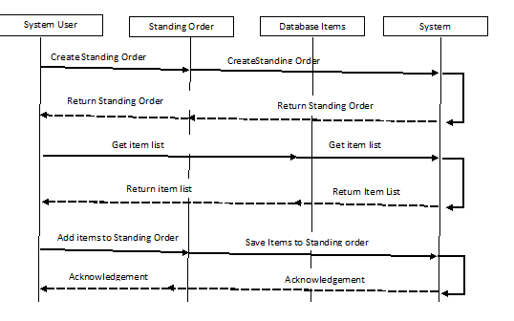

### 8.2 Modify Standing Order

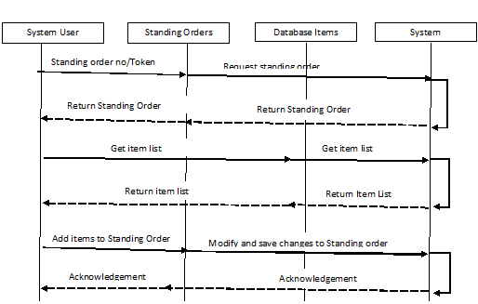

Modify Standing Order Master Details

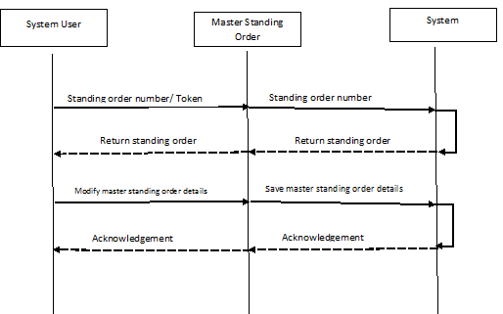

### 8.3 Generate Orders

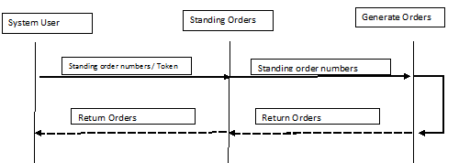

### 8.4 Generate Order

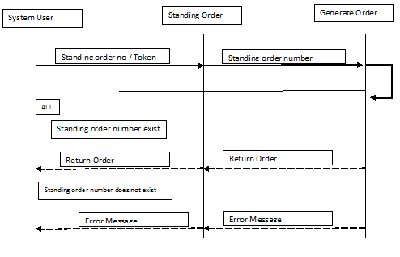

### 8.5 Create Independent Order

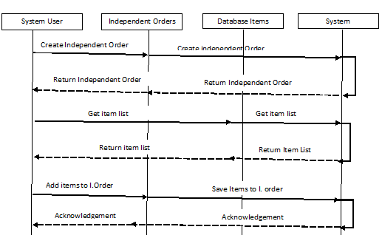

### 8.6 Approve Standing Orders Changes

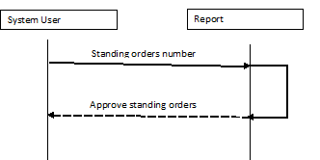

### 8.7 Approve Order Changes

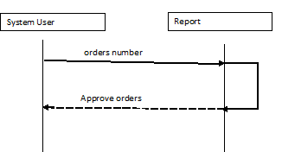

### 8.8 Get Standing Orders

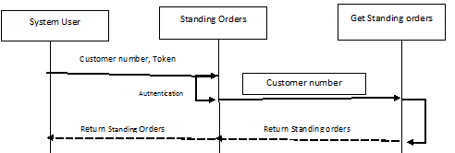

### 8.9 Get Standing Order

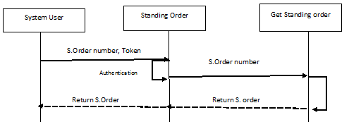

### 8.10 Get Standing Order Items

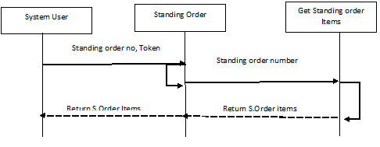

### 8.11 Get Standing Order Item

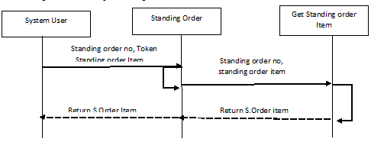

### 8.12 Get orders

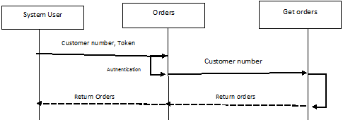

### 8.13 Get order

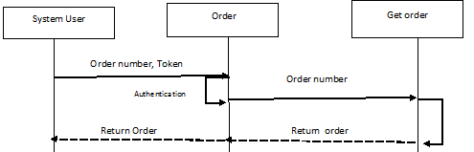

### 8.14 Get Order Items

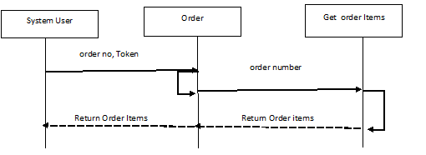

### 8.15 Get order Item

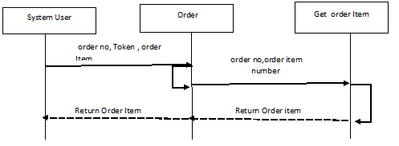

### 8.16 Get Invoice

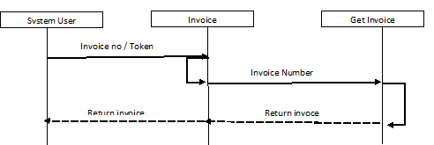

### 8.17 Get Invoices

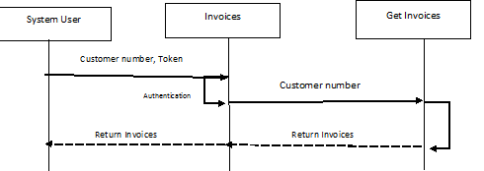

### 8.18 Get Debit/Notes

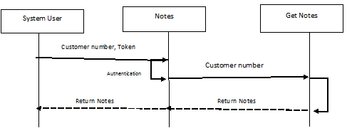

### 8.19 Get Debit/Credit Note

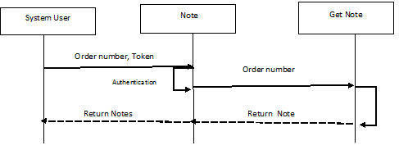

### 8.20 Print Standing Orders

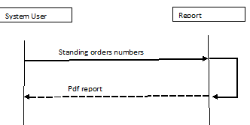

### 8.21 Print Standing Order

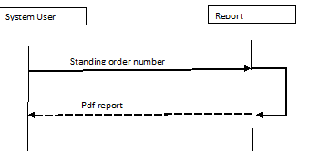

### 8.22 Print Order

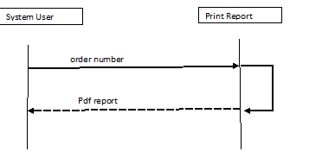

### 8.23 Print Orders

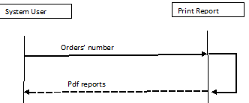

### 8.24 Print Invoices

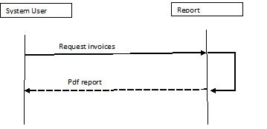

### 8.25 Print Invoice

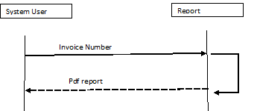

### 8.26 Help

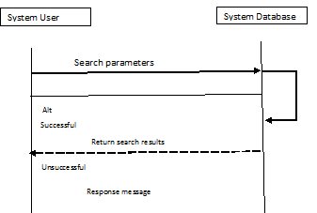

### 8.27 Sync (Get Route Information)

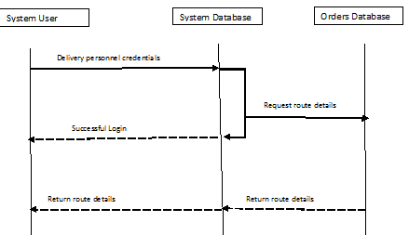

### 8.28 Sync (Upload Transaction)

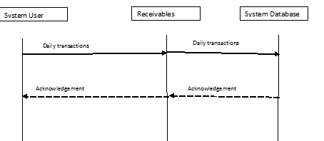

### 8.29 Log IN

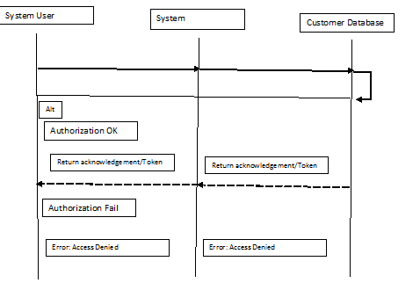

# 9.0 Resource Diagrams

In this section, the resources of the system are described to show the different actions that can be carried out on each of them.

### 9.1 Standing Orders

|  |  |  |  |
| --- | --- | --- | --- |
| Action | Input Parameter | Output | Description |
| GET | Customer No/Token | {Standing Order No, Customer No, Total Items, Total Discount, Status, Standing Day, Created Date} | A list of Standing Orders for a customer is returned. |
| POST | Operation/Token/Data | A Json object (can be true or false) with a string to show the status of request. | Operation= ‘generate’, ‘generateselected’, ‘deleteorders’, ‘changeddate’  Data= *standingdate, *productiondate, *standingorderno, *itemno |
| DELETE | Standing Day/Token | A Json object (can be true or false) with a string to show the status of request. | DELETE ALL standing orders for the given day. |

### 9.2 Standing Order

|  |  |  |  |
| --- | --- | --- | --- |
| Action | Input Parameter | Output | Description |
| GET | Customer No/Token | {Customer No, Total Items, Total Discount, Status, Standing Order No, Standing Day, Created Date, Customer Discount } | Standing Order for a customer is returned. |
| POST | Operation/Token/Data | A Json object (can be true or false) with a string to show the status of request. | Operation= ‘generate’, ‘generateselected’, ‘deleteorders’, ‘changeddate’  Data= *standingdate, *productiondate, *standingorderno, *itemno |
| PUT | Operation/Token/Data | A Json object (can be true or false) with a string to show the status of request. | Operation= ‘create standing order’  Data= *standingdate, *productiondate |
| DELETE | Standing Day/Token | A Json object (can be true or false) with a string to show the status of request. | DELETE the standing order for the given day. |

### 9.3 Orders

|  |  |  |  |
| --- | --- | --- | --- |
| Action | Input Parameter | Output | Description |
| GET | Customer No/Token | {Order No , Customer No, Total Items, Total Discount, Status, Created Date, Customer Discount, Late Order } | A list of Orders for a customer is returned. |
| POST | Operation/Token/Data | A Json object (can be true or false) with a string to show the status of request. | Operation= ‘generate’, ‘generateselected’, ‘deleteorders’, ‘changeddate’  Data= *date, *productiondate, *orderno, *itemno |
| DELETE | Order Date/Token | A Json object (can be true or false) with a string to show the status of request. | DELETE ALL orders for the given day. |

### 9.4 Independent Order

|  |  |  |  |
| --- | --- | --- | --- |
| Action | Input Parameter | Output | Description |
| GET | Customer No/Token | {Order No , Customer No, Total Items, Total Discount, Status, Created Date, Customer Discount, Late Orde} | An independent Order for a customer is returned. |
| POST | Operation/Token/Data | A Json object (can be true or false) with a string to show the status of request. | Operation= ‘generate’, ‘generateselected’, ‘deleteorders’, ‘changeddate’  Data= *date, *productiondate, *orderno, *itemno |
| PUT | Operation/Token/Data | A Json object (can be true or false) with a string to show the status of request. | Operation= ‘create order’  Data= *date, *itemno |
| DELETE | Order Date/Token | A Json object (can be true or false) with a string to show the status of request. | DELETE the order for the given day. |

### 9.5 Invoices

|  |  |  |  |
| --- | --- | --- | --- |
| Action | Input Parameter | Output | Description |
| GET | Customer No/Token | {Invoice No , Customer No, Total Items, Total Discount, Status, Created Date, Description, Qty} | A list of Invoices for a customer is returned. |
| POST | Operation/Token/Data | A Json object (can be true or false) with a string to show the status of request. | Operation= ‘generate’, ‘generateselected’, ‘deleteinvoices’, ‘changeddate’  Data= *invoiceno, *orderno, *itemno |
| DELETE | Invoice Date/Token | A Json object (can be true or false) with a string to show the status of request. | DELETE ALL invoices for the given day. |

### 9.6 Invoice

|  |  |  |  |
| --- | --- | --- | --- |
| Action | Input Parameter | Output | Description |
| GET | Customer No/Token | {Invoice No , Customer No, Total Items, Total Discount, Status, Created Date, Description, Qty} | An Invoice for a customer is returned. |
| PUT | Operation/Token/Data | A Json object (can be true or false) with a string to show the status of request. | Operation= ‘create’, ‘deleteinvoices’  Data= *invoiceno, *orderno, *itemno |
| POST | Operation/Token/Data | A Json object (can be true or false) with a string to show the status of request. | Operation= ‘generate’, ‘generateselected’, ‘deleteinvoices’, ‘changeddate’  Data= *invoiceno, *orderno, *itemno |
| DELETE | Invoice Date/Token | A Json object (can be true or false) with a string to show the status of request. | DELETE invoice for the given day. |

### 9.7 Credit/Debit Notes

|  |  |  |  |
| --- | --- | --- | --- |
| Action | Input Parameter | Output | Description |
| GET | NoteNo/Token | {Note No, Discrepancy Comment,Return Items, Invoice No} | A list of credit/debit notes for a customer is returned. |
| PUT | Operation/Token/Data | A Json object (can be true or false) with a string to show the status of request. | Operation= ‘create’, ‘changeddate’  Data= *date, *noteno |
| POST | Operation/Token/Data | A Json object (can be true or false) with a string to show the status of request. | Operation= ‘generate’, ‘generateselected’, ‘changeddate’  Data= *noteno, *invoiceno, *itemno |

### 9.8 Credit/Debit Note

|  |  |  |  |
| --- | --- | --- | --- |
| Action | Input Parameter | Output | Description |
| GET | NoteNo/Token | {Note No, Discrepancy Comment,Return Items, Invoice No} | A credit/debit note for a customer is returned. |
| PUT | Operation/Token/Data | A Json object (can be true or false) with a string to show the status of request. | Operation= ‘create’, ‘changeddate’  Data= *date,*noteno |
| POST | Operation/Token/Data | A Json object (can be true or false) with a string to show the status of request. | Operation= ‘generate’, ‘generateselected’, ‘changeddate’  Data= *noteno, *invoiceno, *itemno |

# 10.0 Graphical User Interface Designs (GUIs)

This section gives an illustration of how each page will be designed.

## 10.1 Order Processing Module

### 10.1.1 Desktop Version

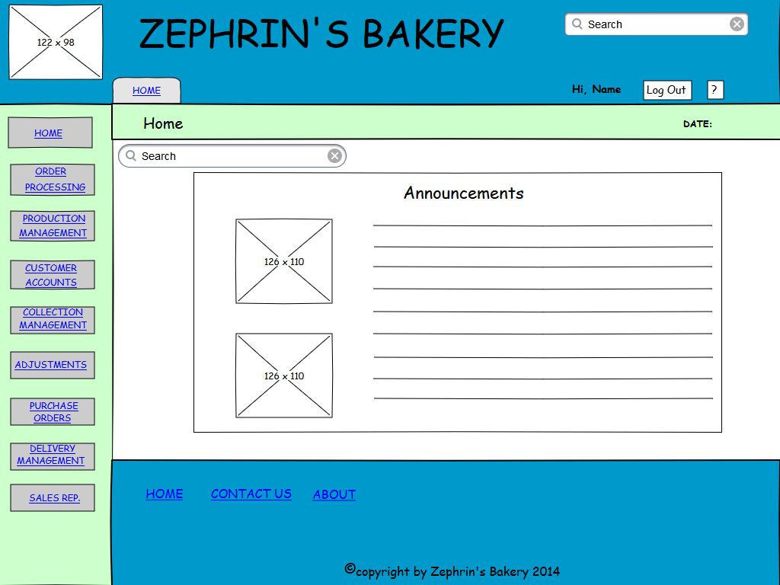

*This figure shows the home page layout when the office clerk signs in*

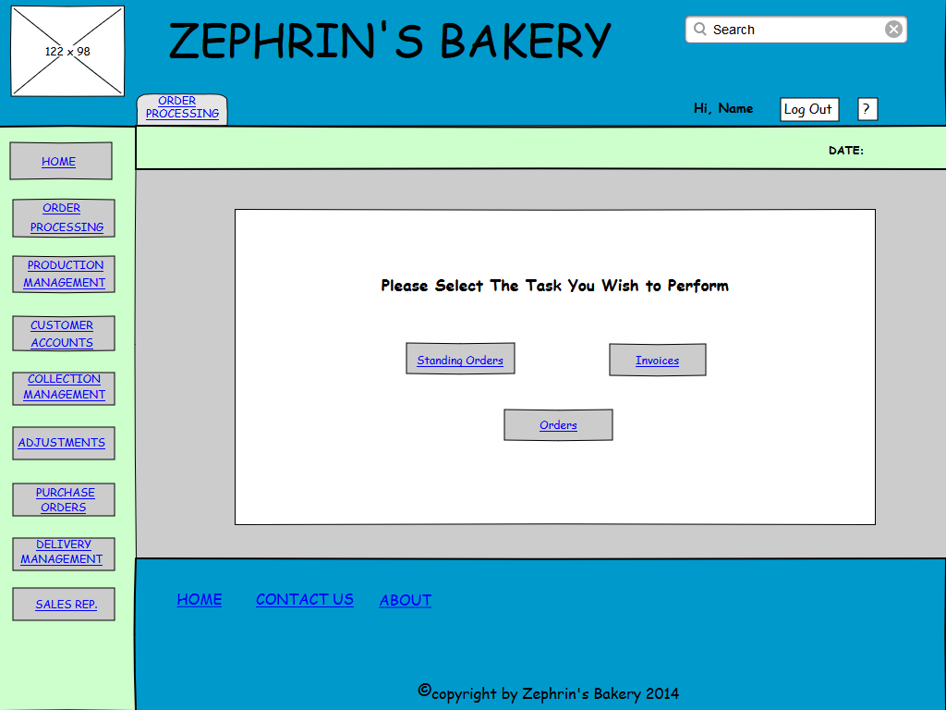

*This figure shows the main page layout for the order processing module*

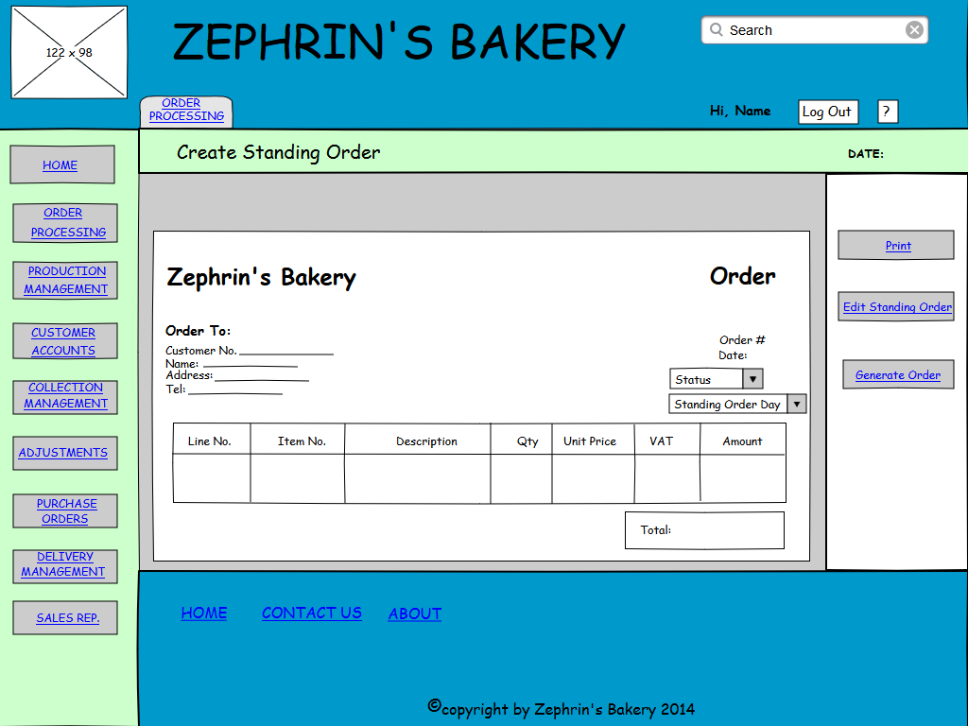

*This figure shows the main page layout for creating a standing order*

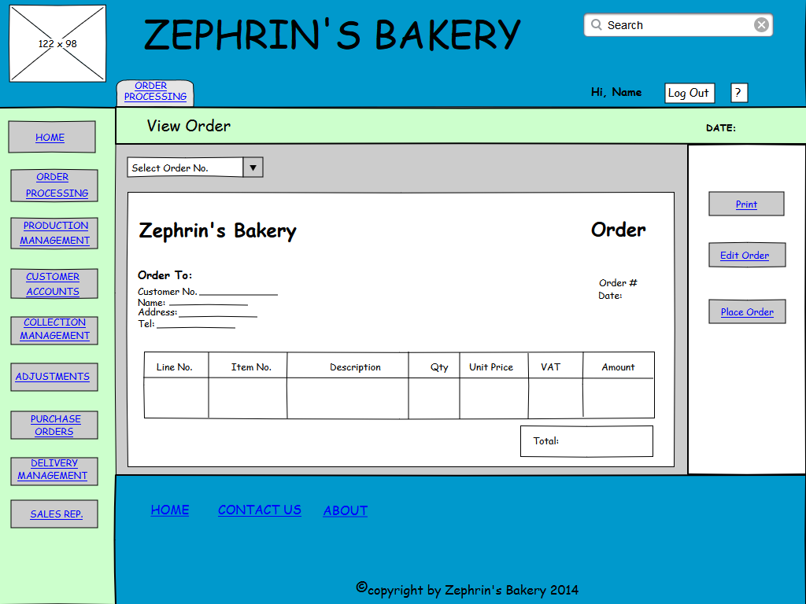

*This figure shows the page layout for viewing an order*

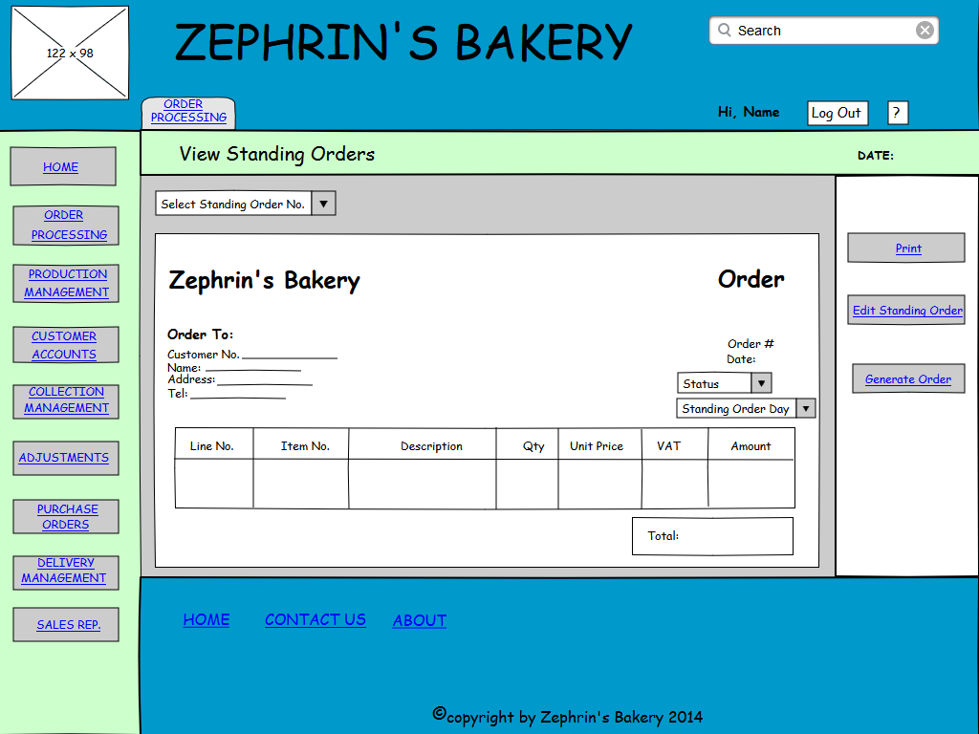

*This figure shows the page layout viewing a standing order*

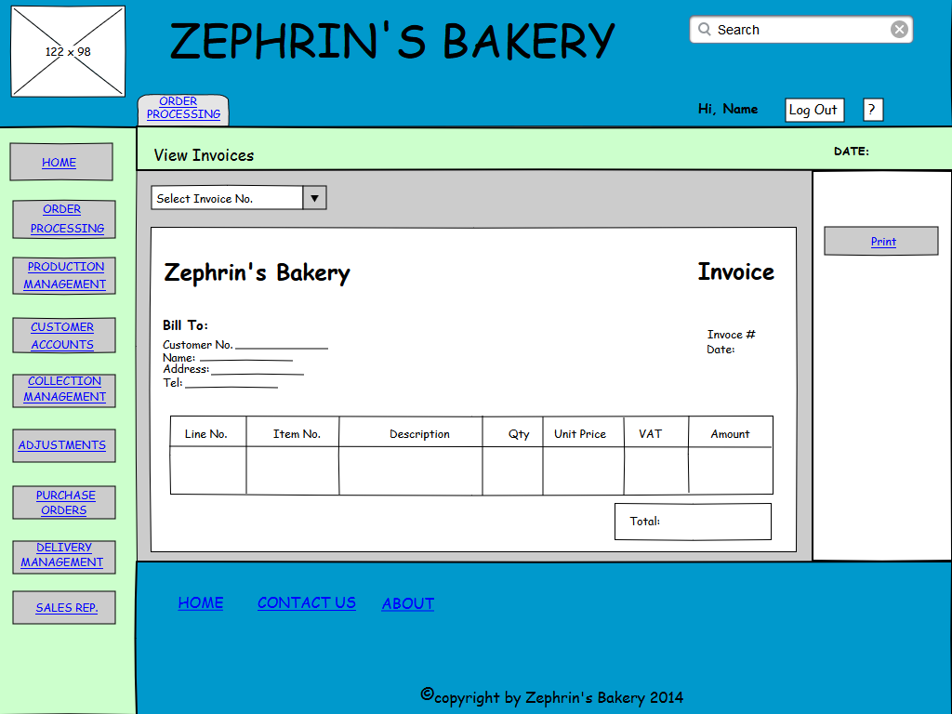

*This figure shows the page layout viewing an invoice*

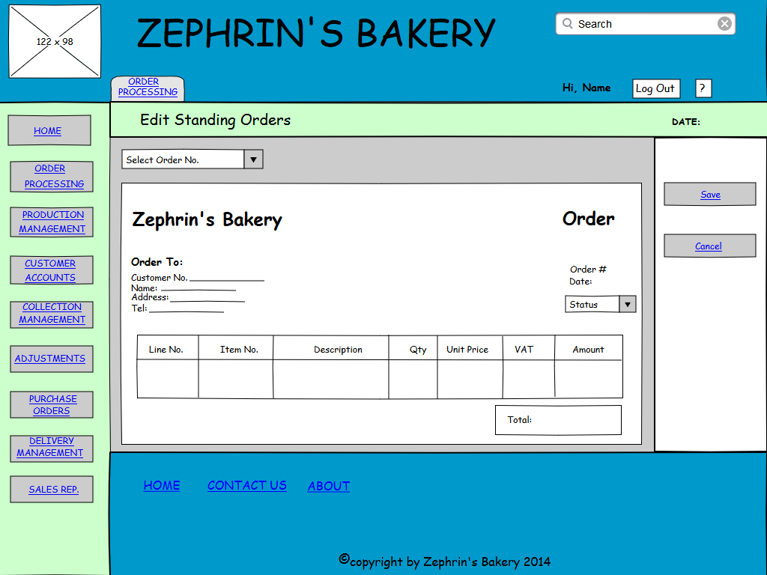

*This figure shows the page layout editing a standing order*

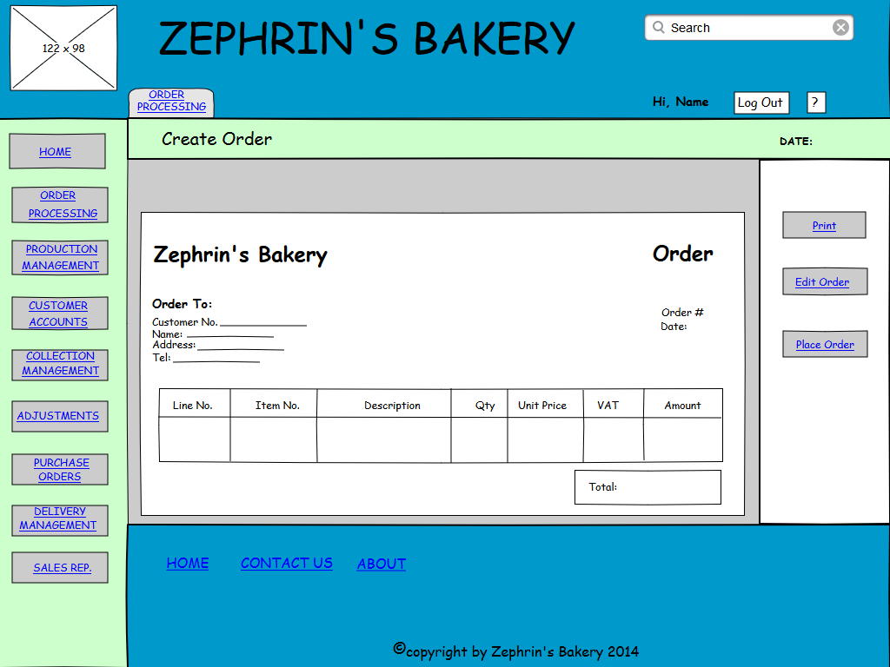

*This figure shows the page layout for creating an order*

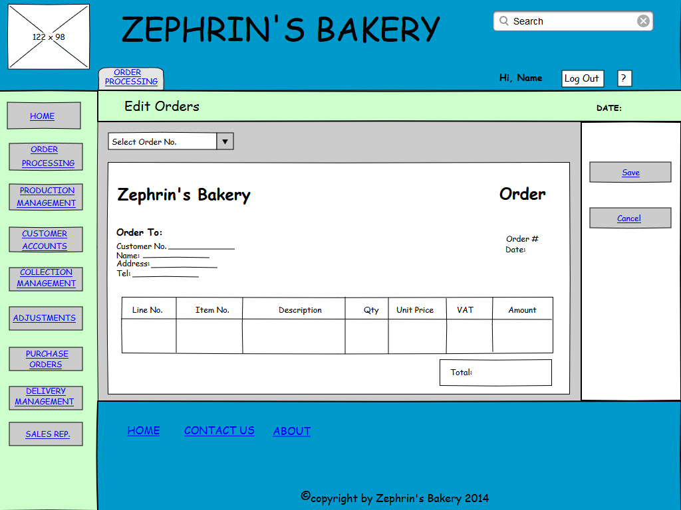

*This figure shows the page layout editing an order*

## 10.2 Customer App’s Module

### 10.2.1 Tablet Version

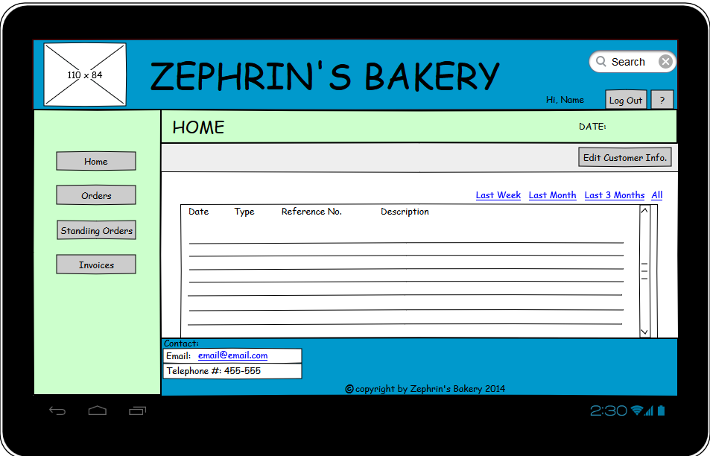

*This figure shows the home page layout when a customer signs in*

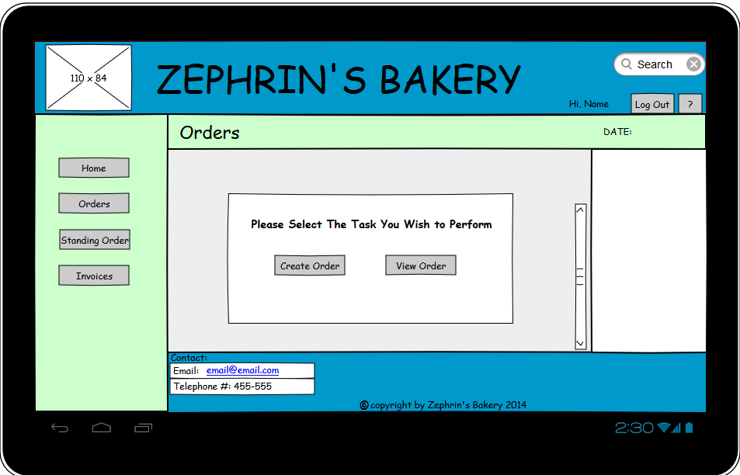

*This figure shows the main page layout for order*

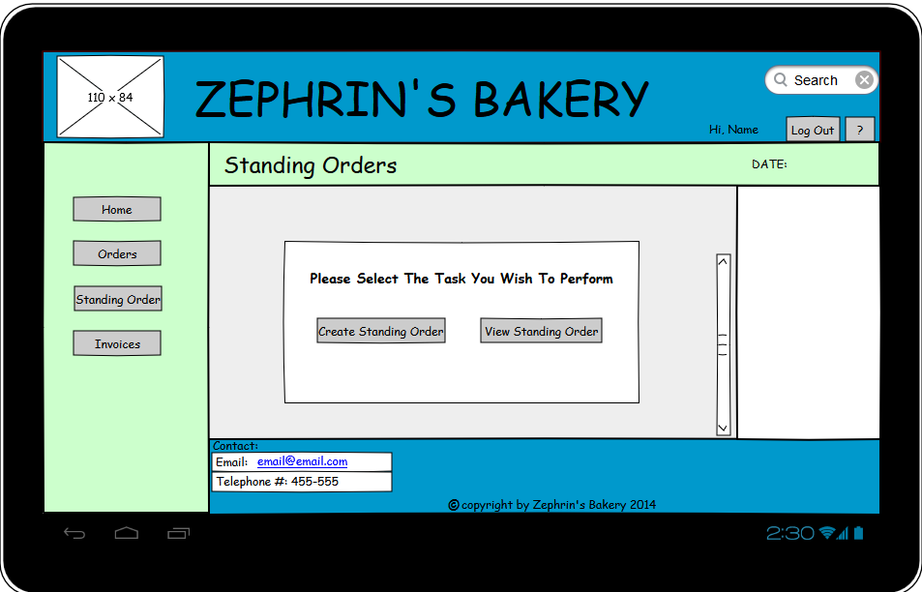

*This figure shows the main page layout for standing orders*

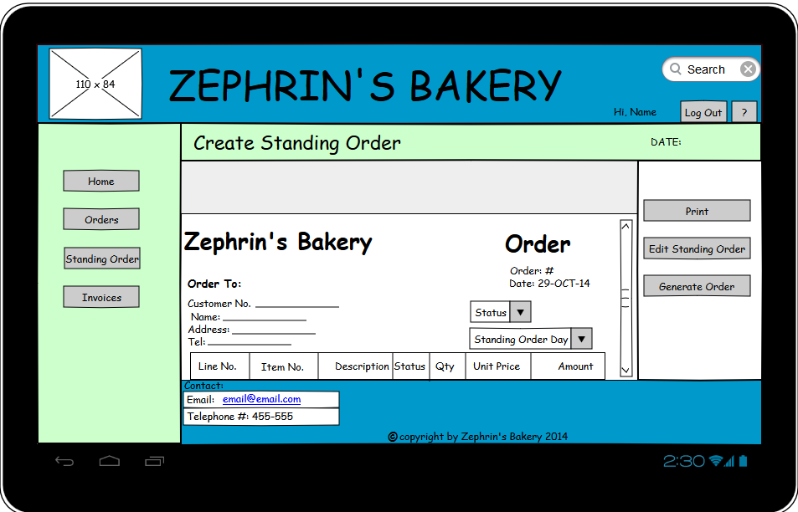

*This figure shows the main page layout for creating a standing order*

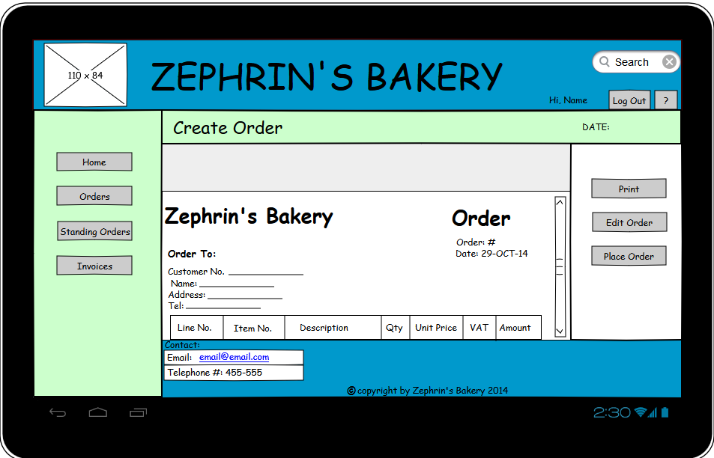

*This figure shows the main page layout for creating an order*

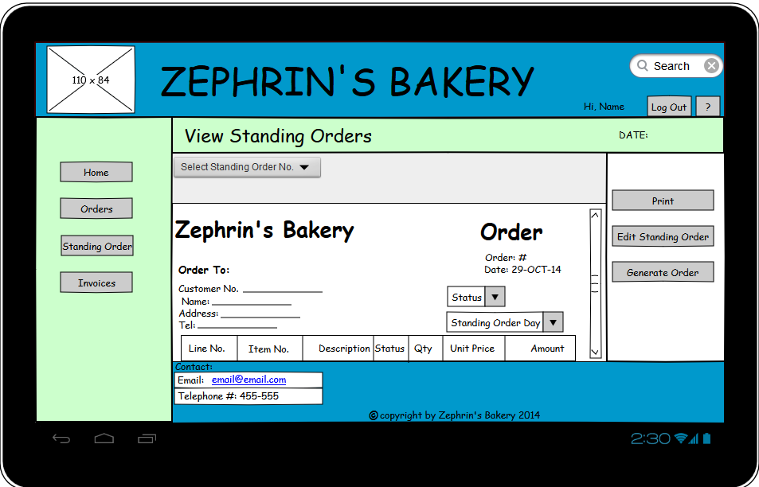

*This figure shows the main page layout for viewing a standing order*

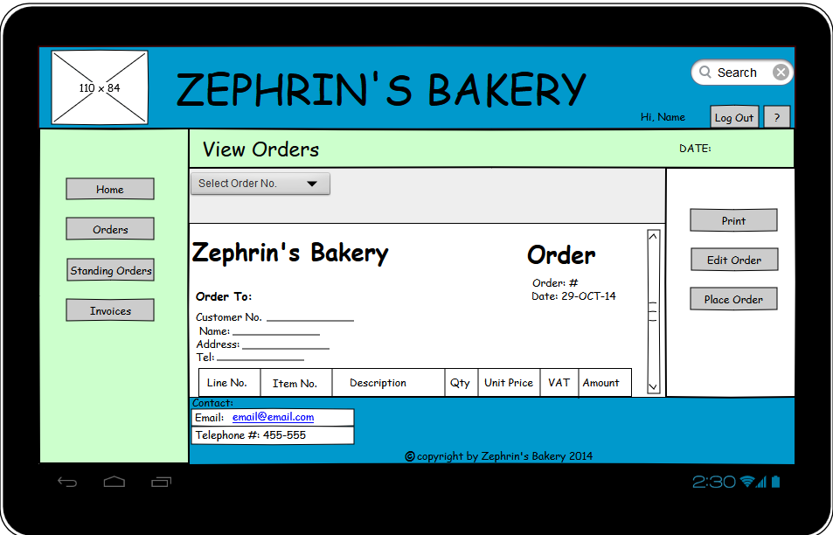

*This figure shows the page layout for viewing an order*

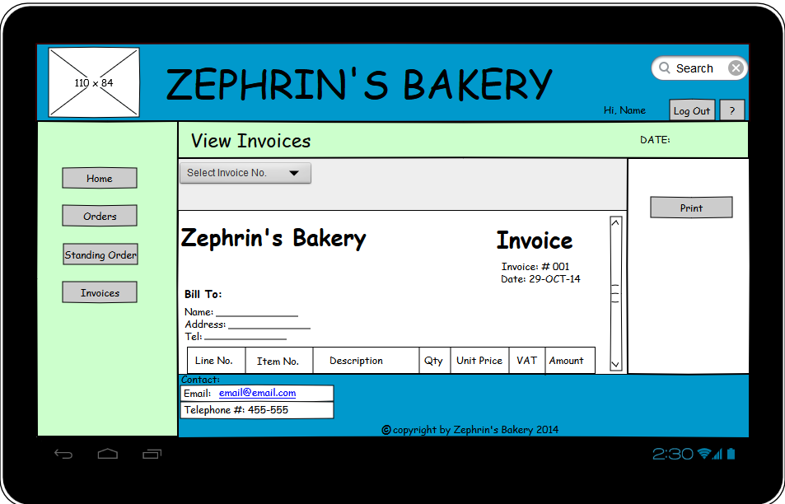

*This figure shows the main page layout for viewing an invoice*

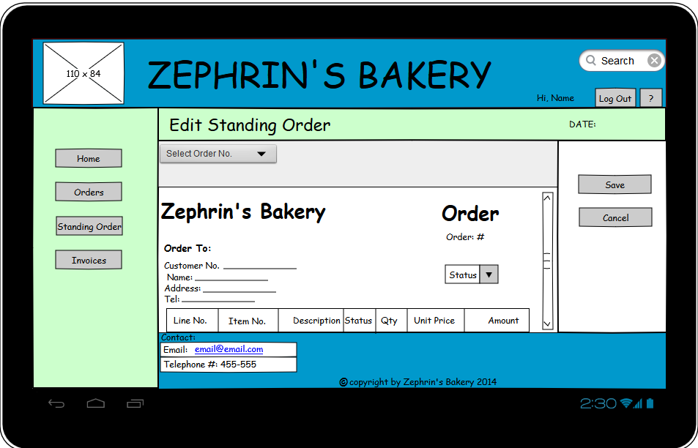

*This figure shows the main page layout for editing a standing order*

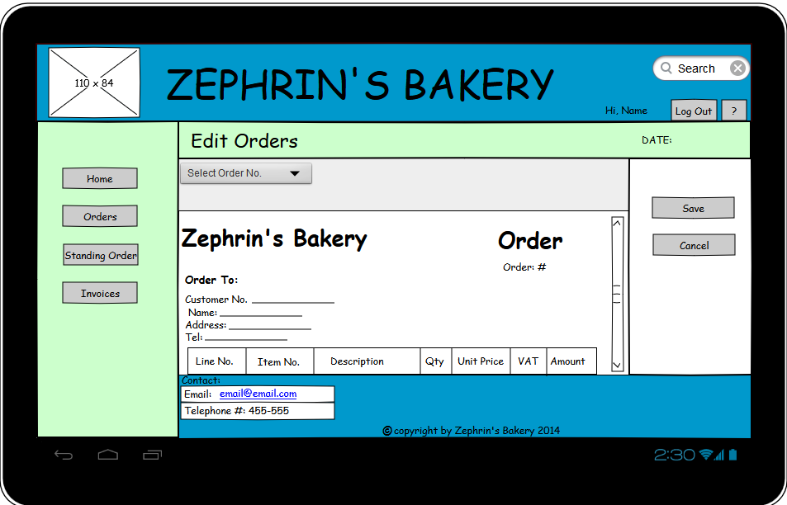

*This figure shows the main page layout for editing an order*

### 10.2.2 Mobile Version

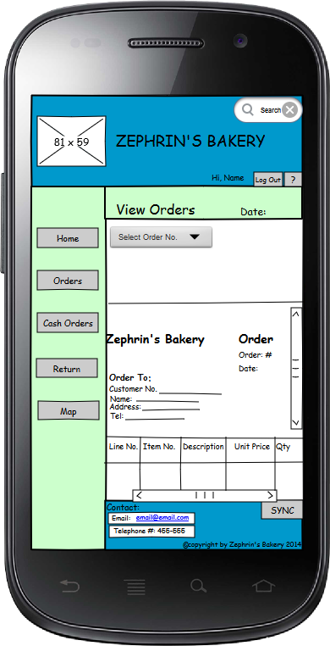

*This figure shows the main page layout for viewing an order*

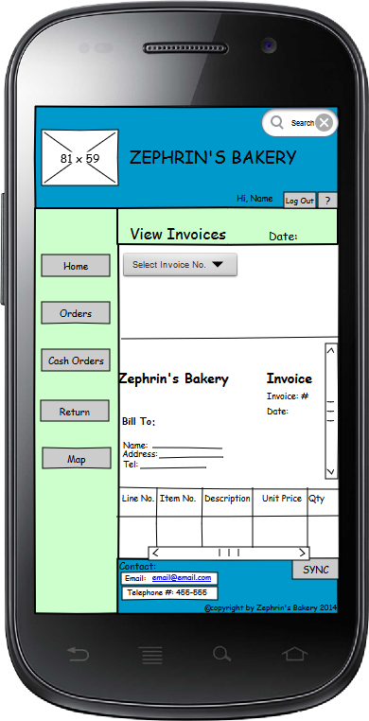

*This figure shows the main page layout for viewing an invoice*

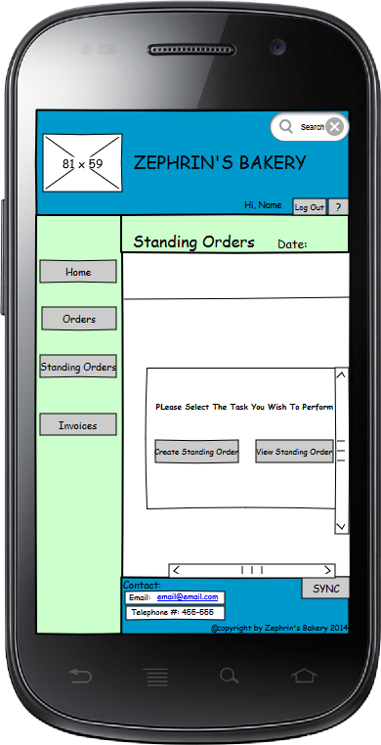

*This figure shows the main page layout for standing order*

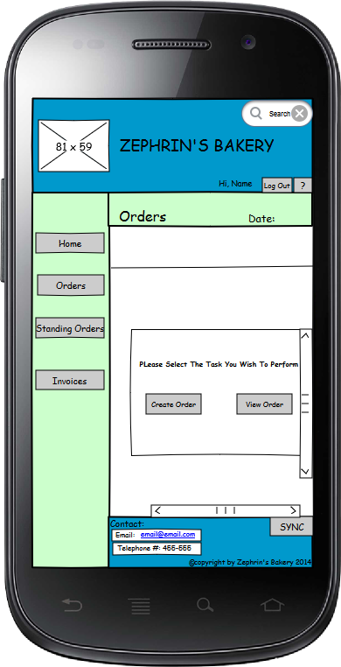

*This figure shows the main page layout for orders*

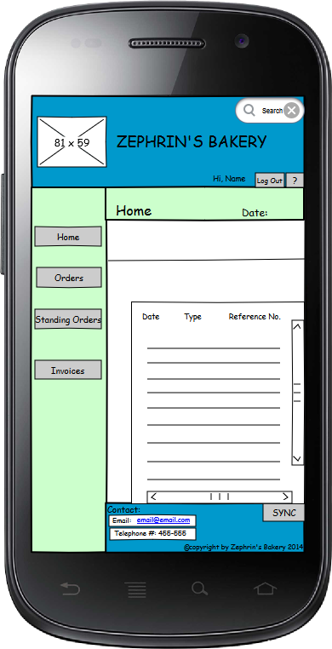

*This figure shows the home page layout for when a customer signs in*

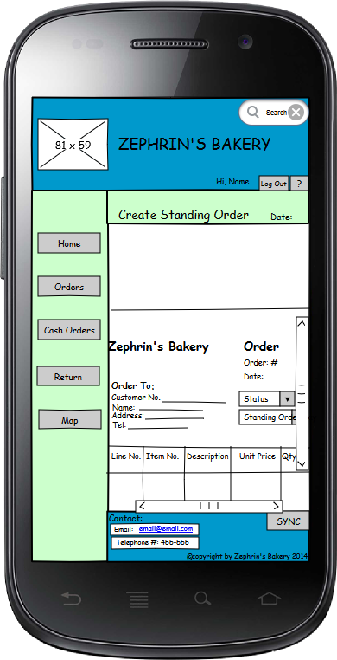

*This figure shows the main page layout for creating a standing order*

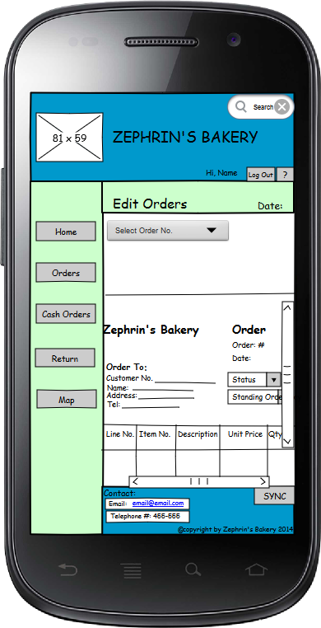

*This figure shows the main page layout for editing an order*

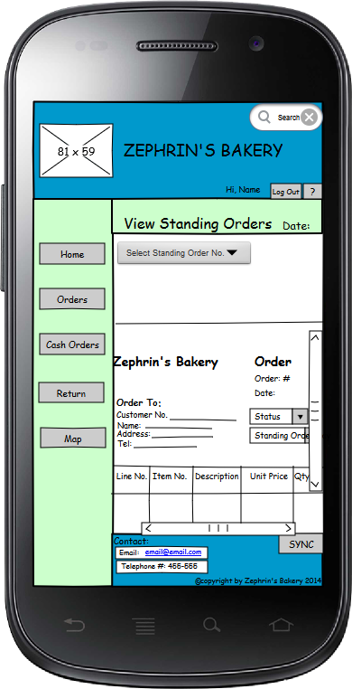

*This figure shows the main page layout for viewing a standing order*

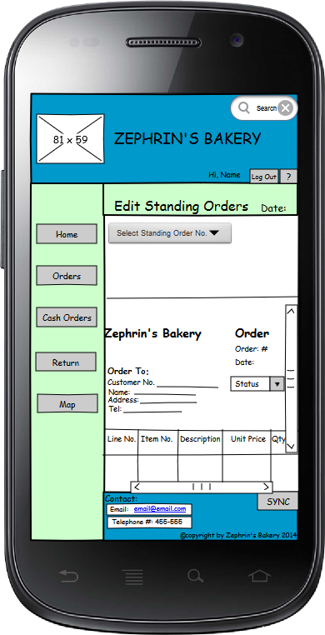

*This figure shows the main page layout for editing a standing order*

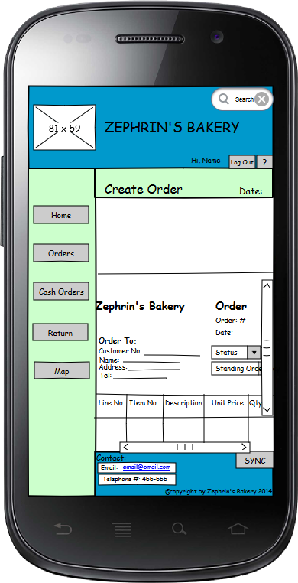

*This figure shows the main page layout for creating an order*

### 10.2.3 Desktop Version

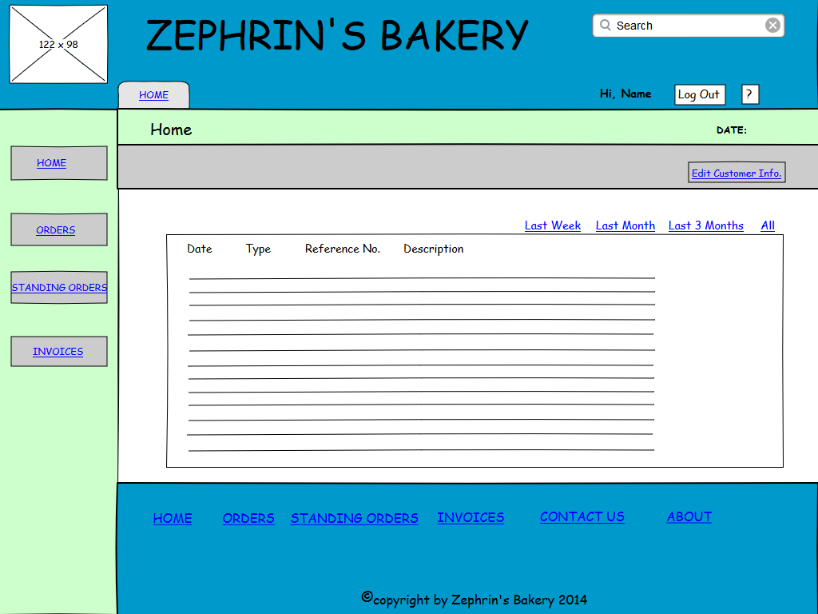

*This figure shows the home page when a customer signs in*

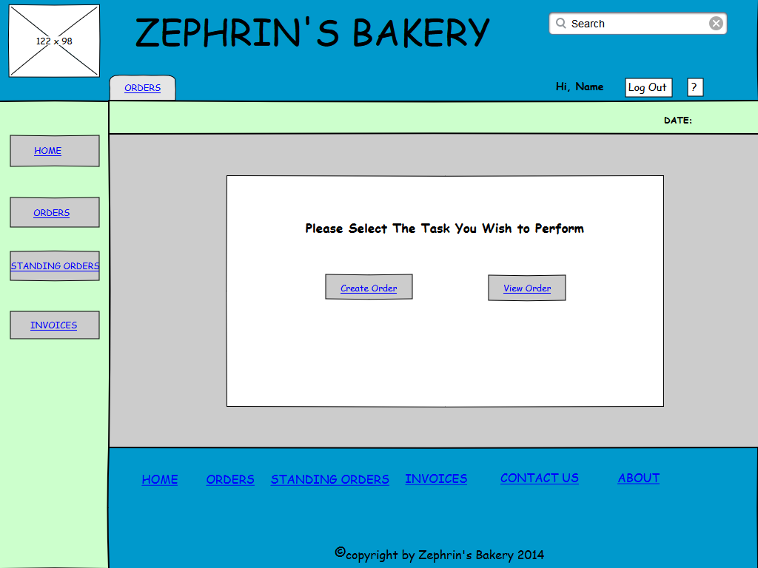

*This figure shows the main page layout for orders*.

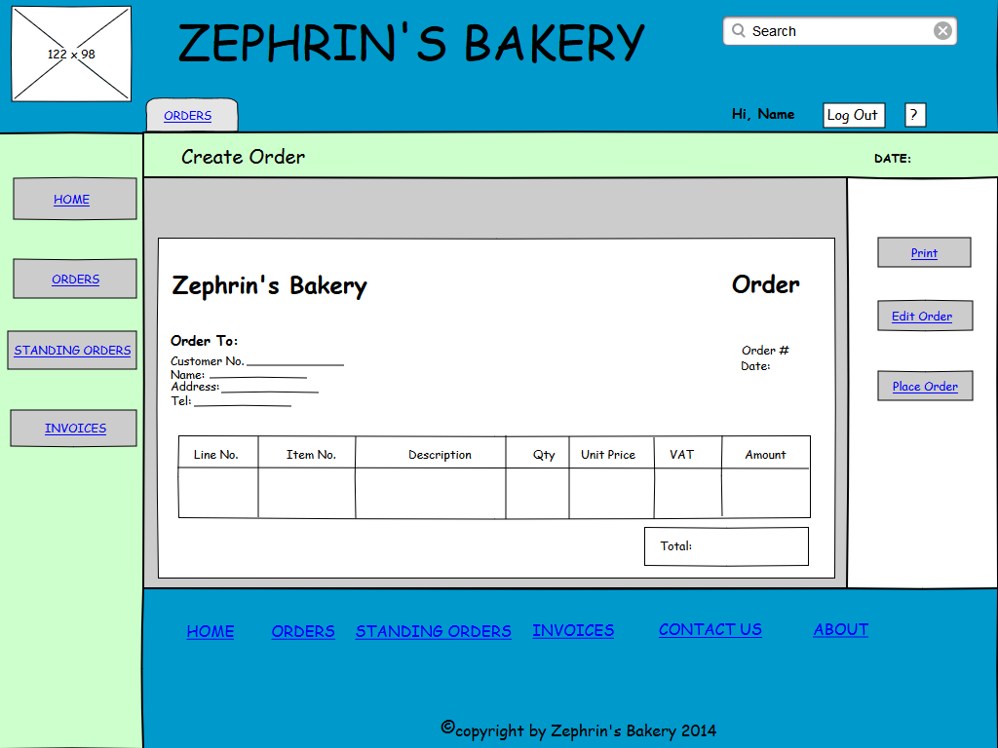

*This figure shows the main page layout for creating an order*

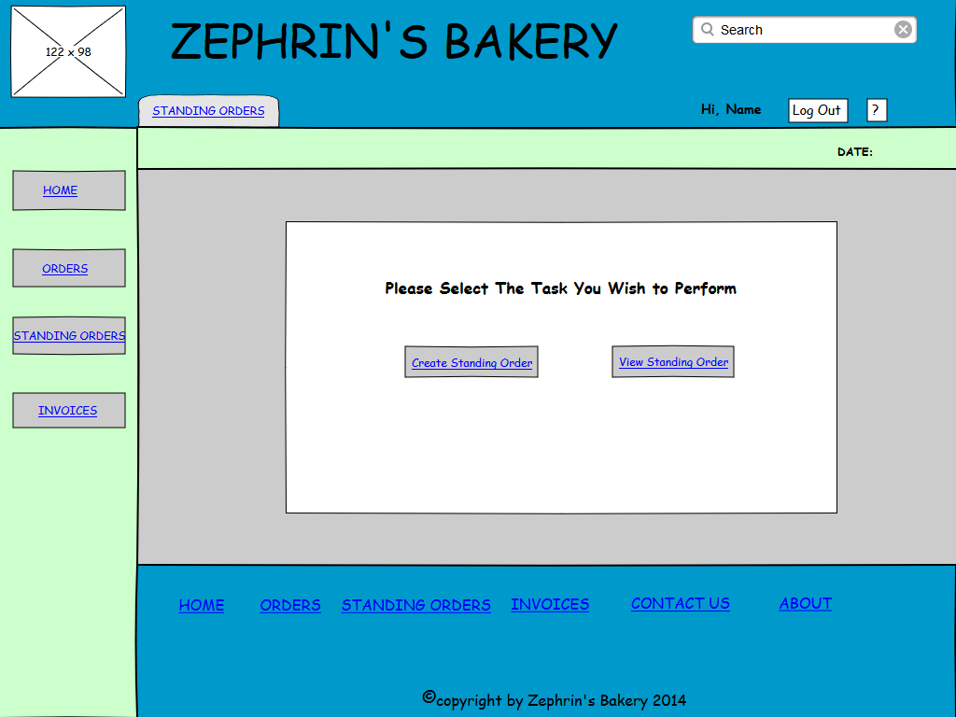

*This figure shows the main page layout for standing orders*

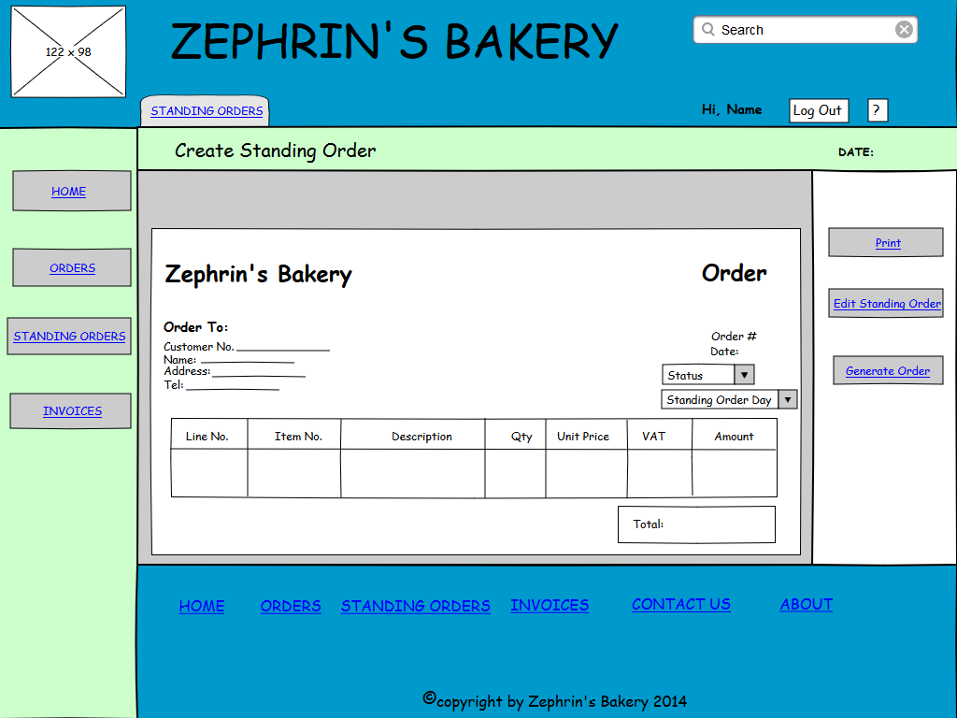

*This figure shows the main page layout for creating a standing order*

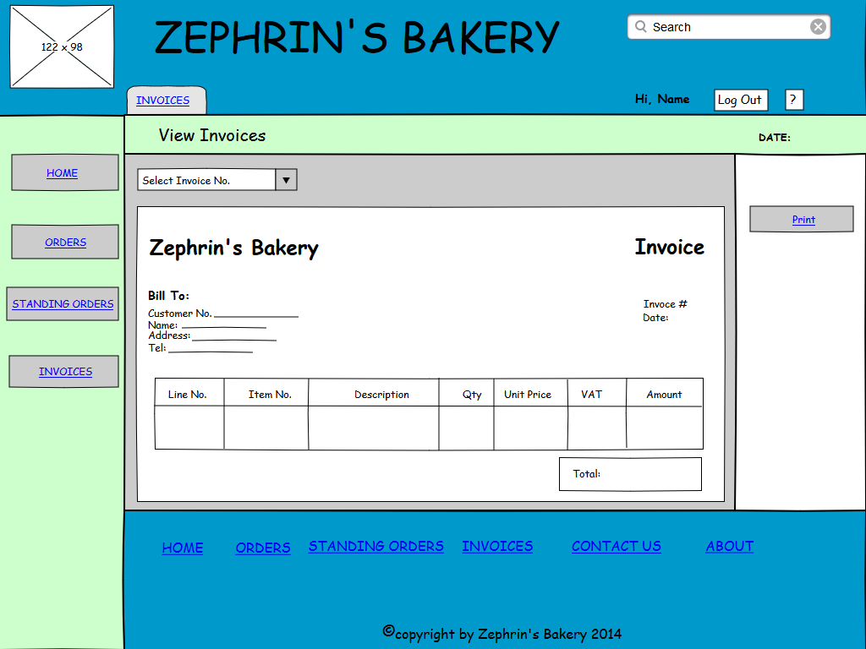

*This figure shows the page layout for viewing an invoice*

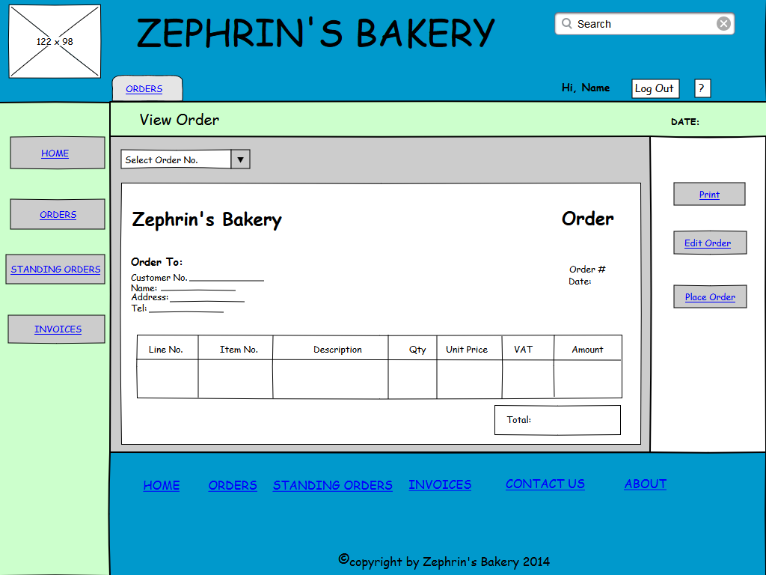

*This figure shows the main page layout for viewing an order*

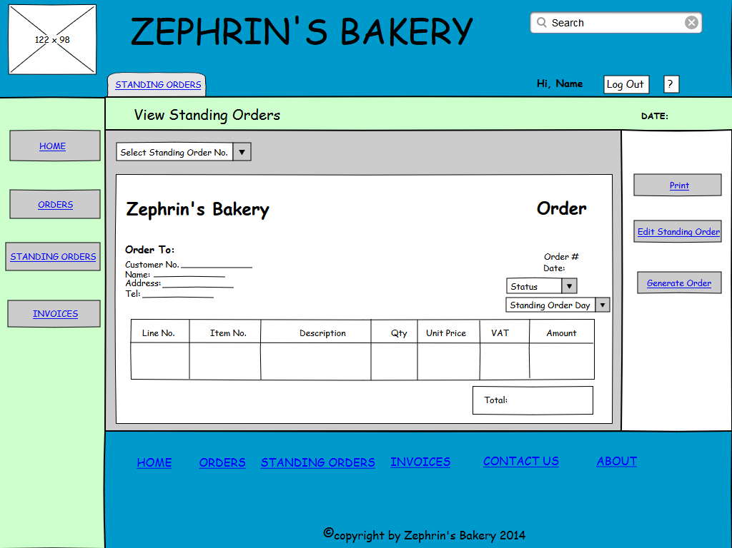

*This figure shows the main page layout for viewing a standing order*

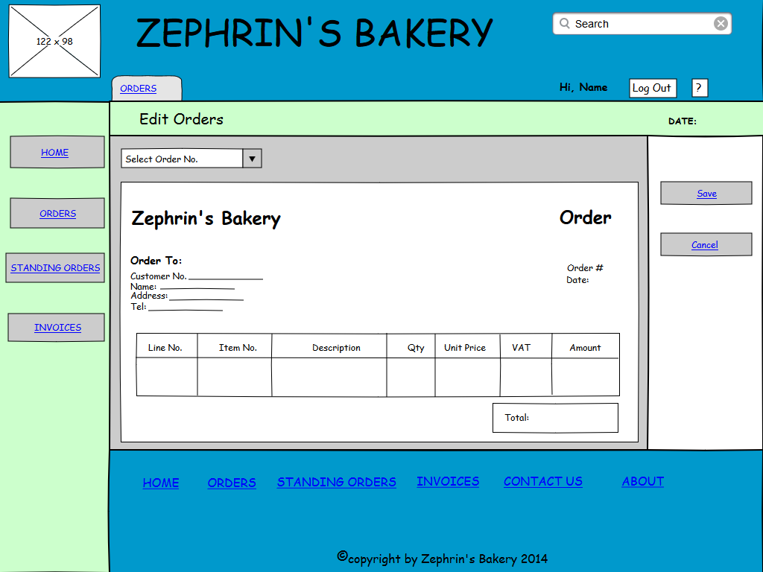

*This figure shows the main page layout for editing an order*

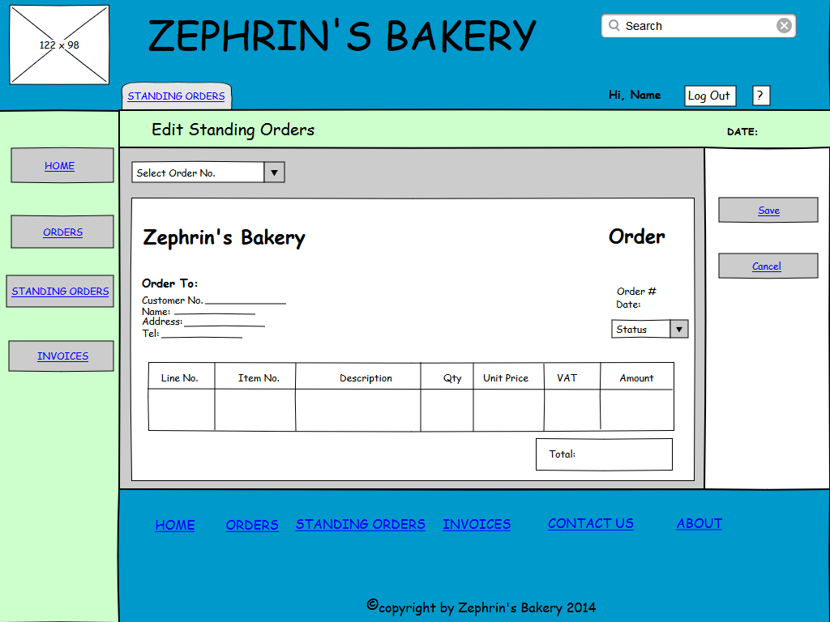

*This figure shows the main page layout for editing a standing order*

## 10.3 Merchandiser App’s Module

### 10.3.1 Tablet Version

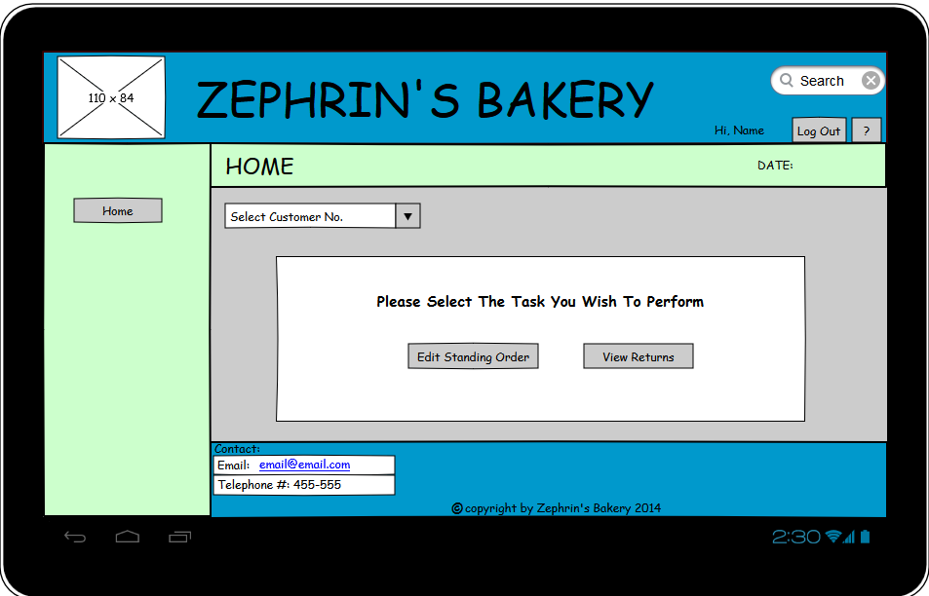

*This figure shows the home page layout for merchandisers.*

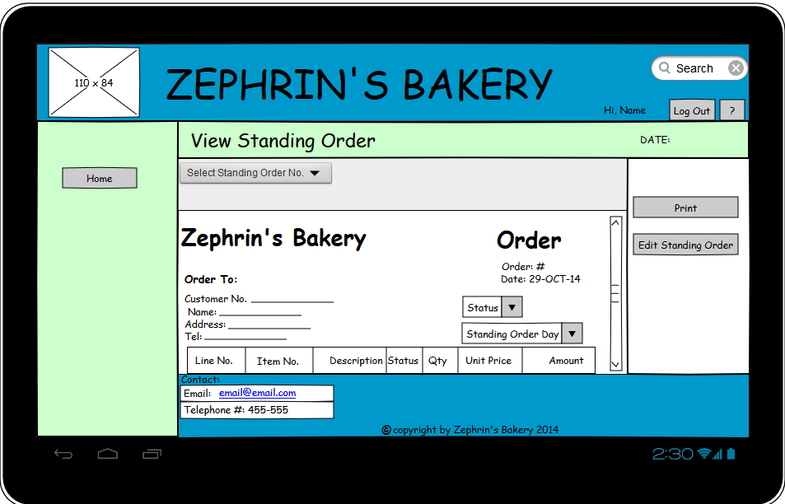

*This figure shows the page layout for viewing an order.*

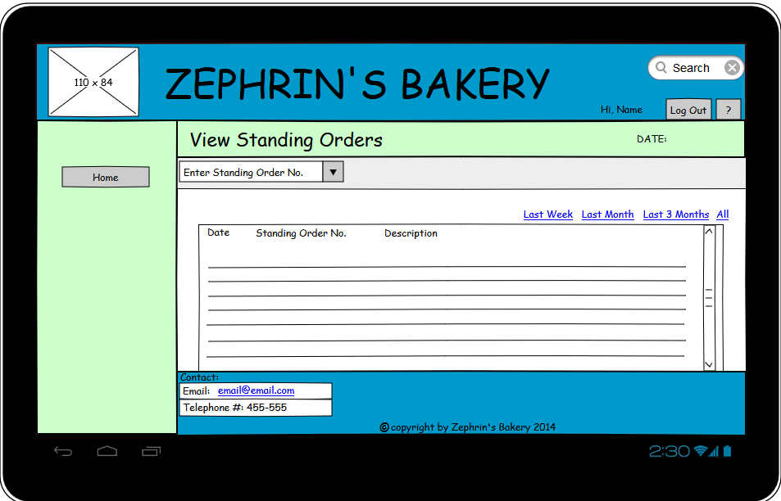

*This figure shows the page layout for viewing standing order*

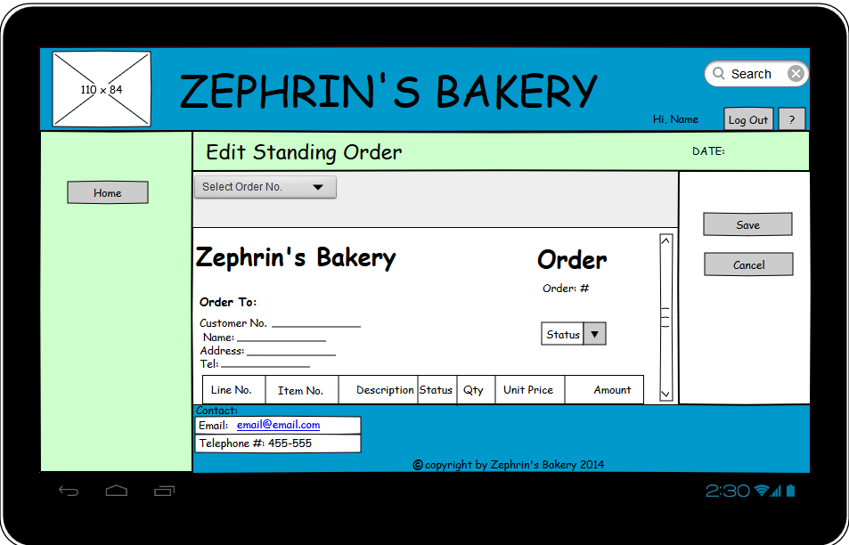

*This figure shows the main page layout for editing a standing order*

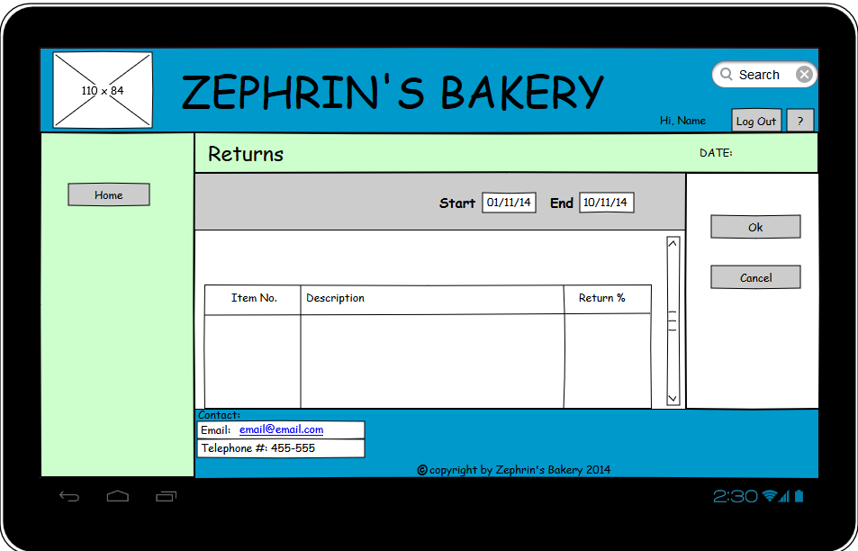

*This figure shows the page layout for returns*

### 10.3.2 Mobile Version

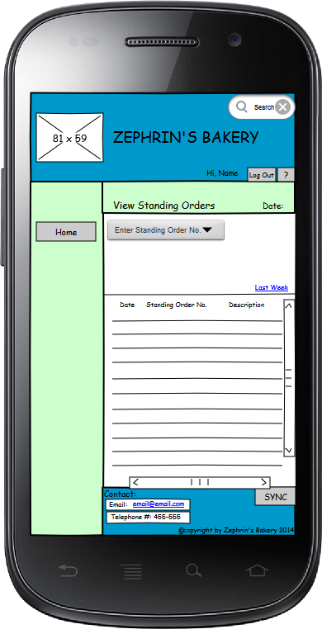

*This figure shows the main page layout for viewing standing orders*

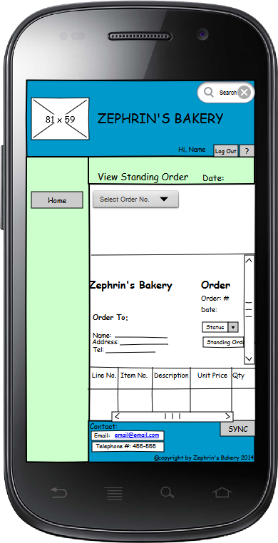

*This figure shows the main page layout for viewing a standing order*

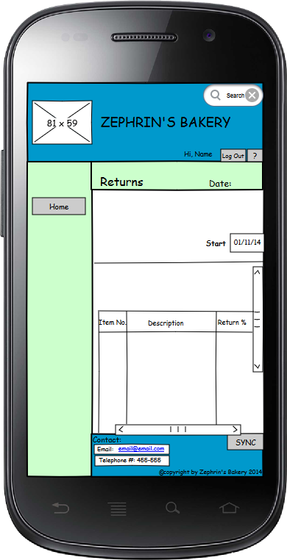

*This figure shows the page layout for viewing returns for a customer*

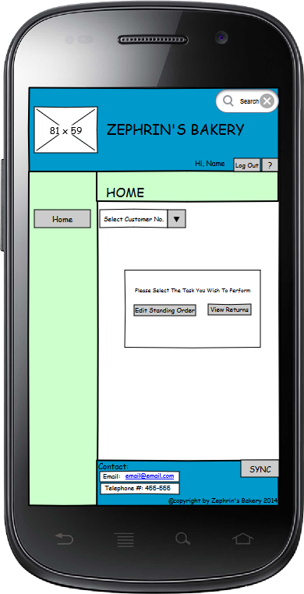

*This figure shows the home page layout for when a merchandiser*

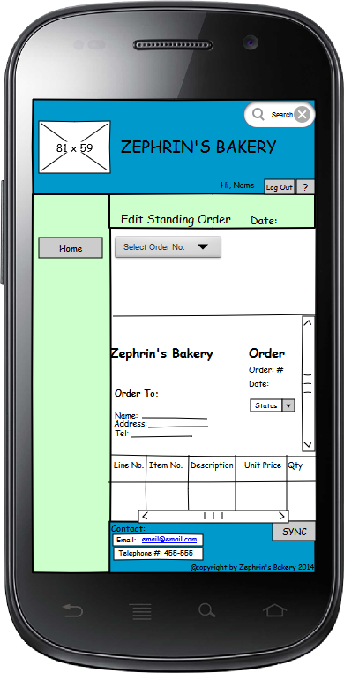

*This figure shows the main page layout for editing a standing order.*

### 10.3.3 Desktop Version

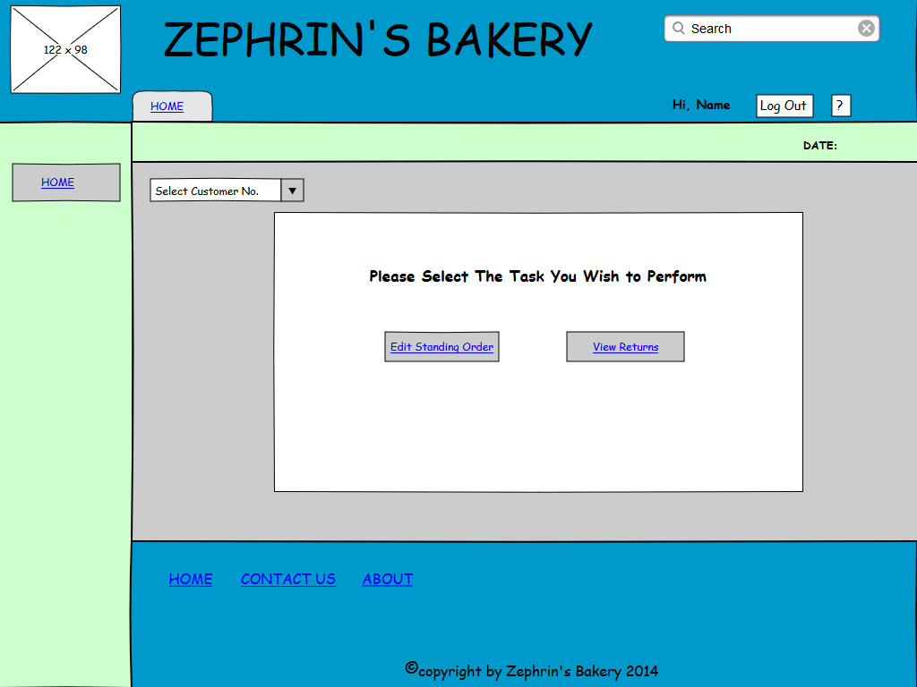

*This figure shows the home page layout for merchandisers*

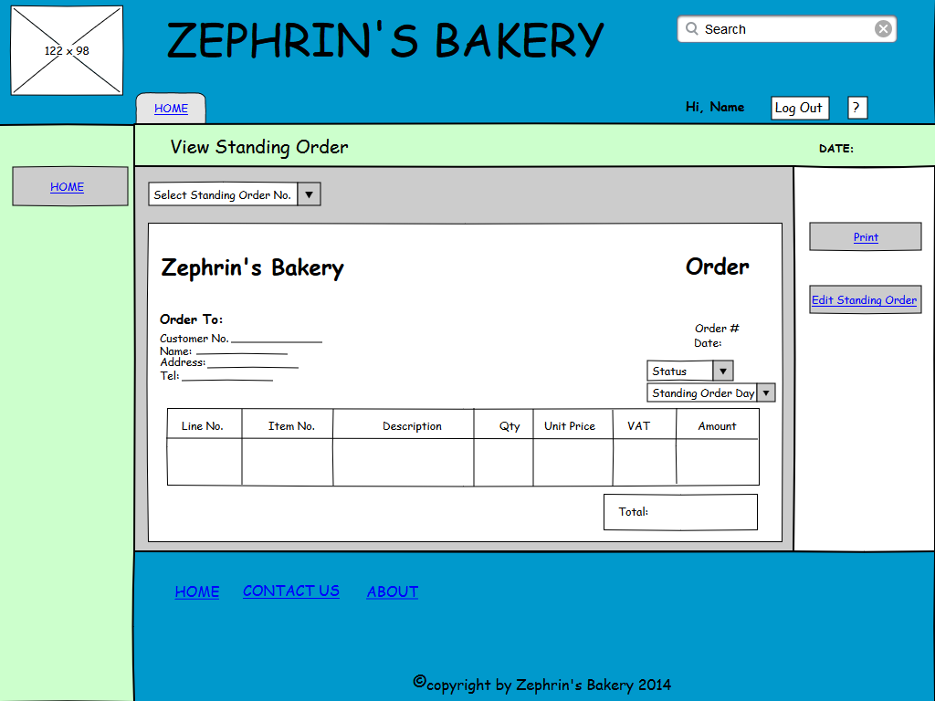

*This figure shows the main page layout for viewing a standing order*

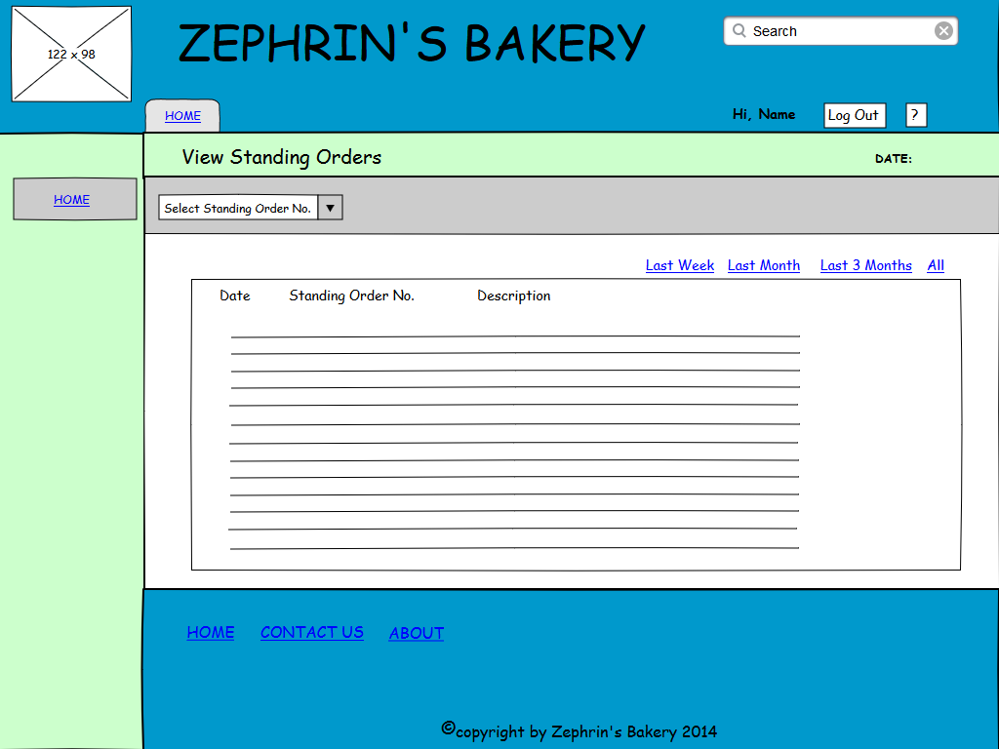

*This figure shows the main page layout for viewing standing orders*

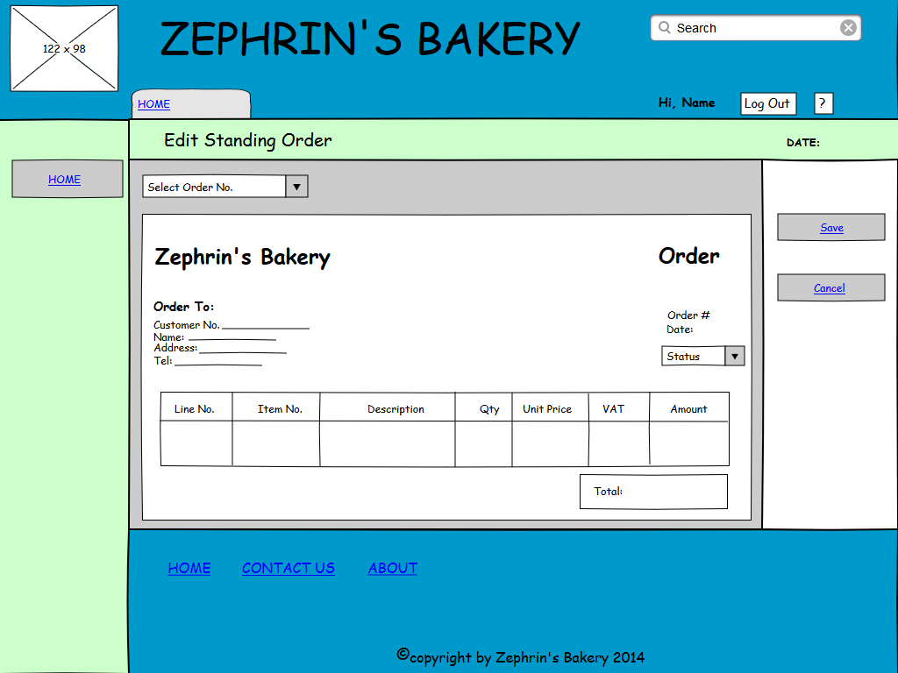

*This figure shows the main page layout for editing a standing orders*

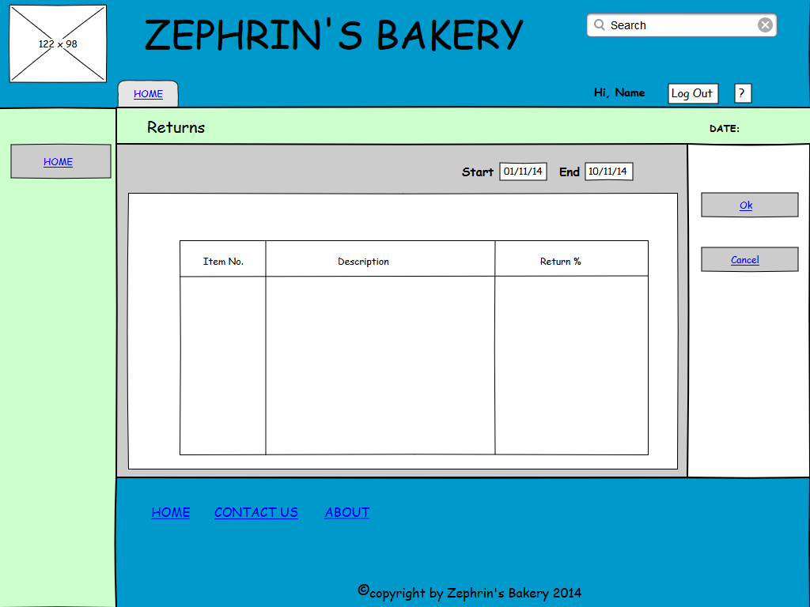

*This figure shows the main page layout for viewing returns.*

## 10.4 Delivery App’s Module

### 10.4.1 Tablet Version

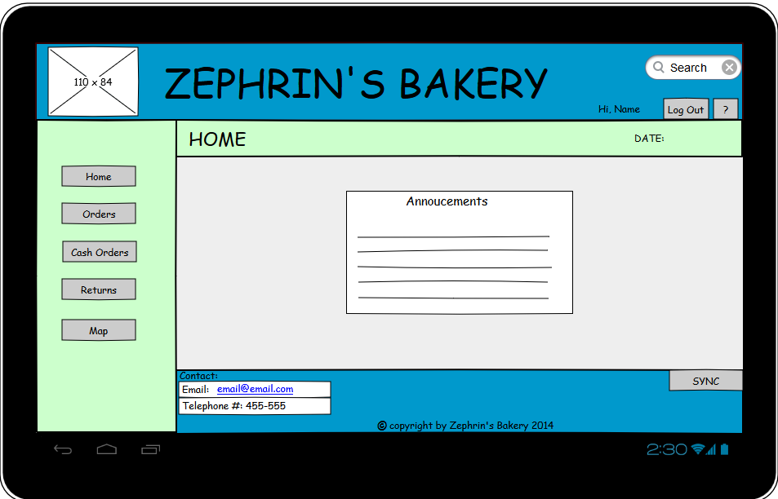

*This figure shows the home page for delivery app*

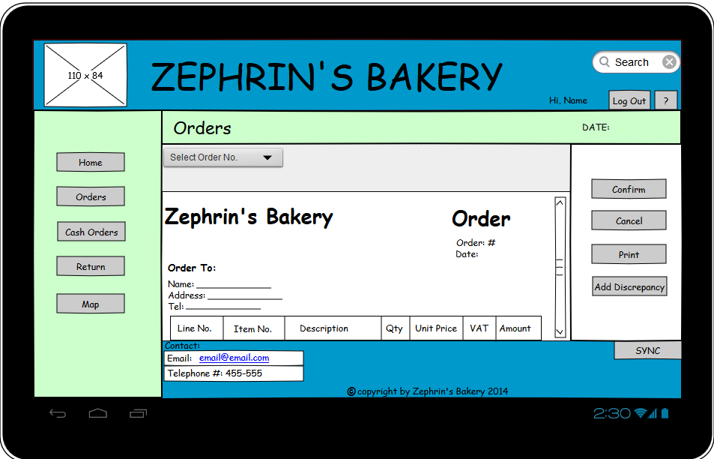

*This figure shows the page layout for viewing an order*

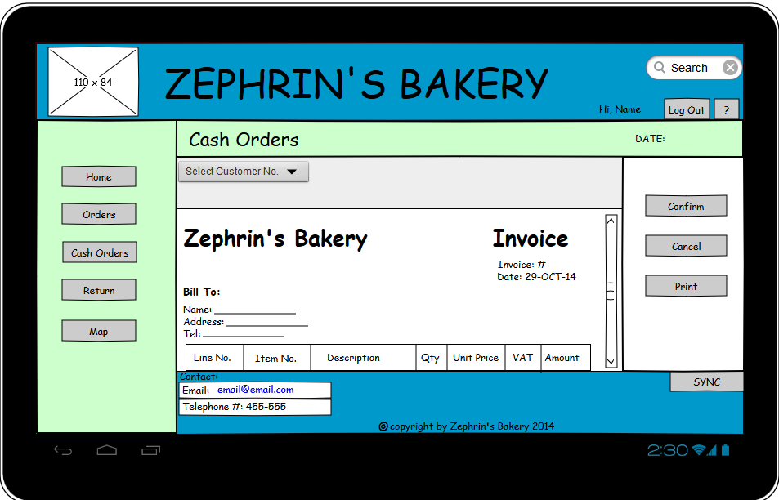

*This figure shows the page layout for creating a cash orders*

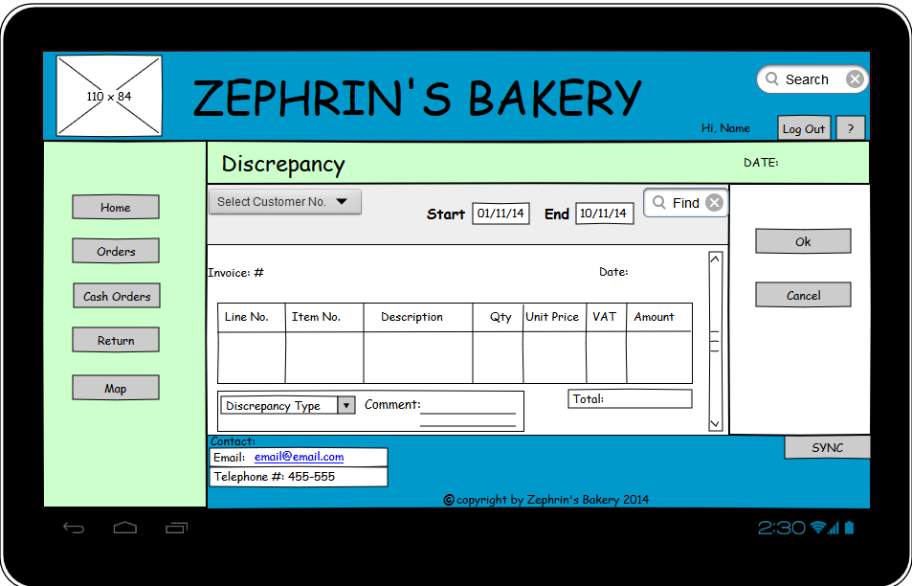

*This figure shows the main page layout for viewing discrepancies.*

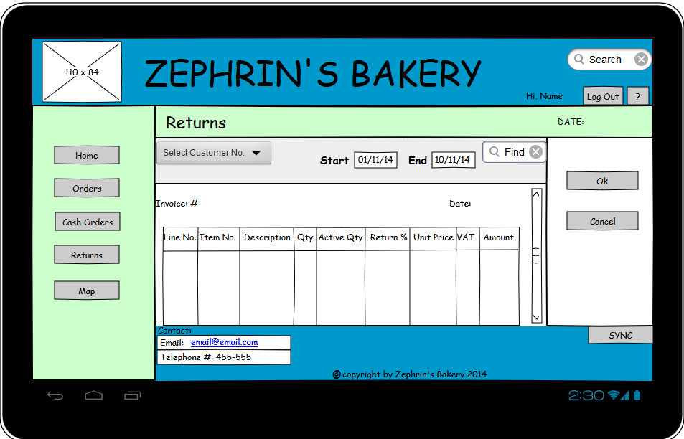

*This figure shows the main page layout for viewing standing returns*

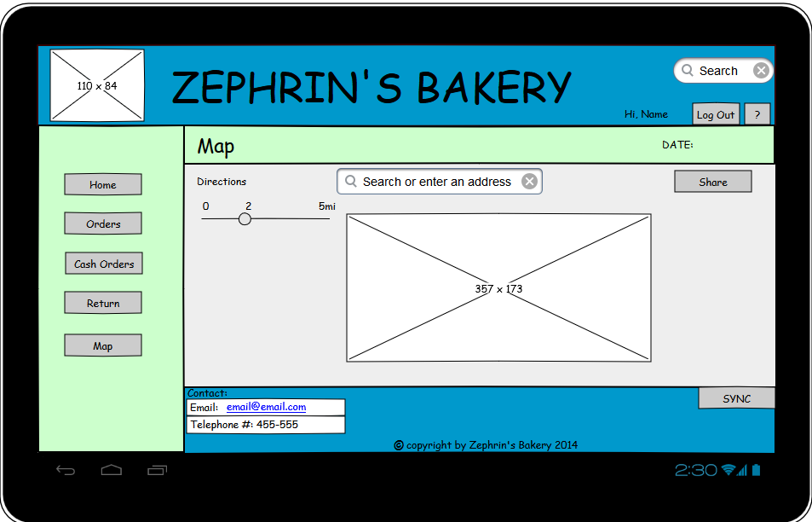

*This figure shows the main a map indicating the stop points on the route.*

### 10.4.2 Mobile Version

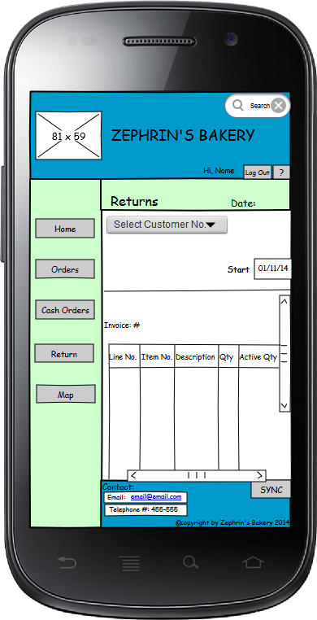

*This figure shows the page layout for viewing returns.*

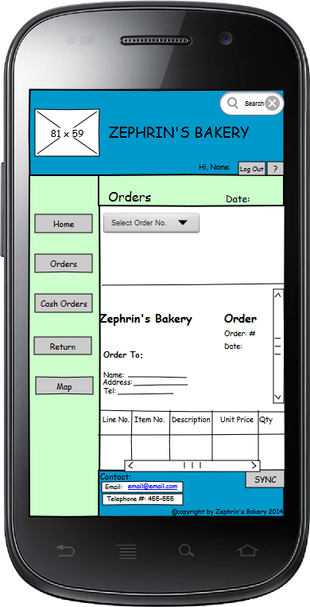

*This figure shows the main page layout for viewing standing orders*

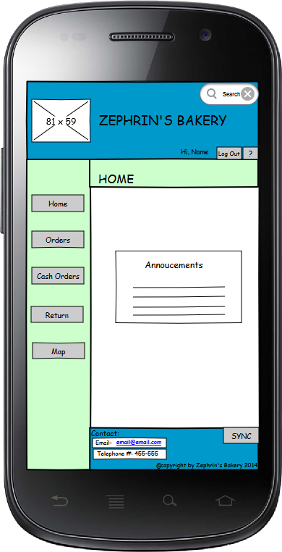

*This figure shows the page layout for the home page of the delivery app*

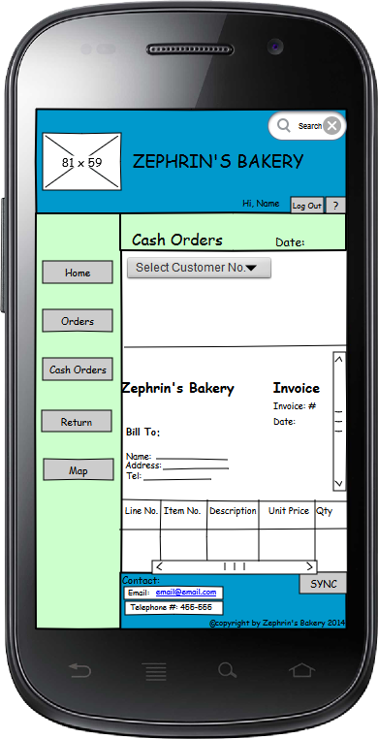

*This figure shows the page layout for creating invoices for cash sales.*

### 10.4.3 Desktop Version

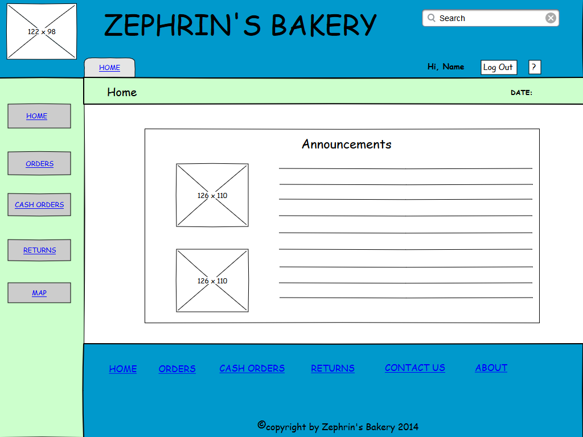

*This figure shows the home page for the delivery’s app*

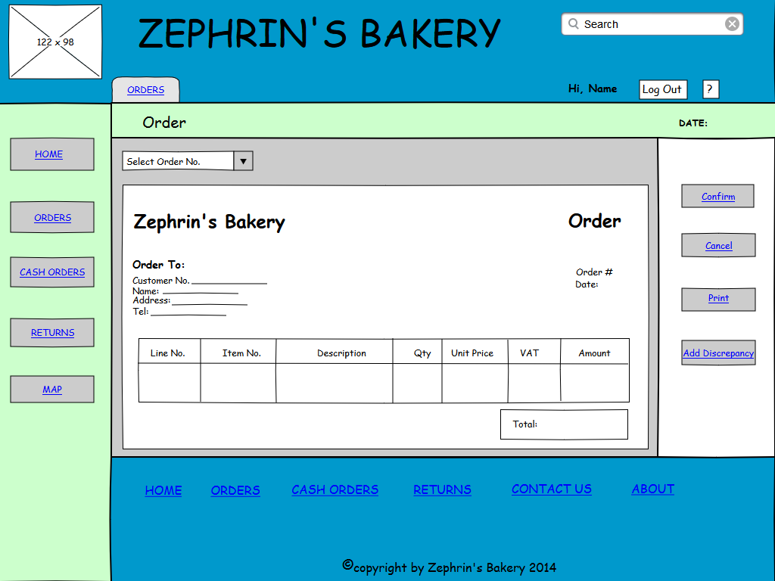

*This figure shows the main page layout for viewing an order*

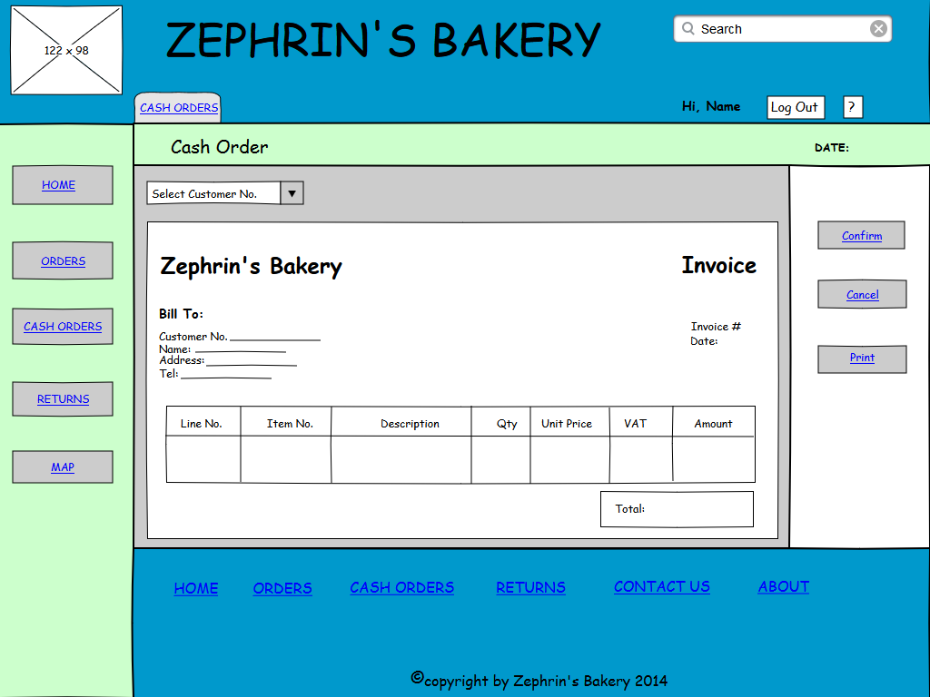

*This figure shows the main page layout for creating an invoice for a cash sales.*

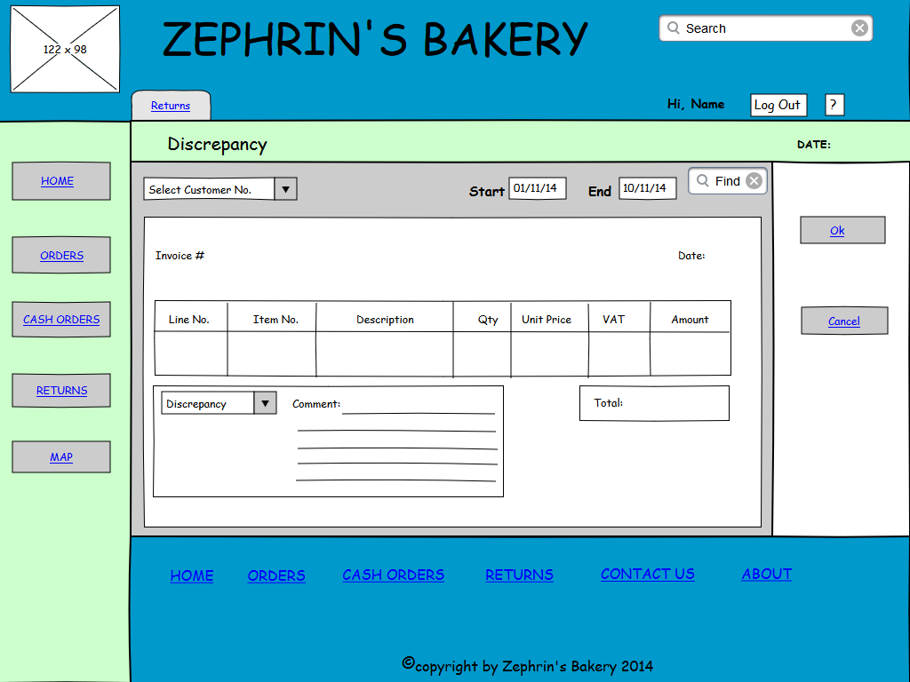

*This figure shows the main page layout for discrepancies.*

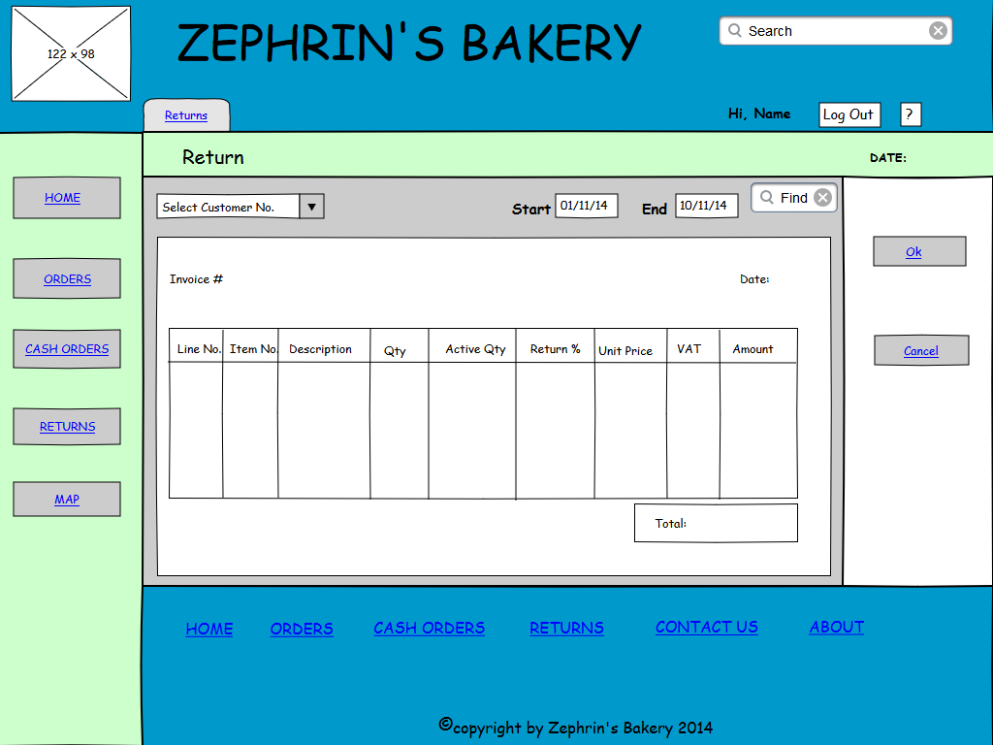

*This figure shows the main page layout for returns.*

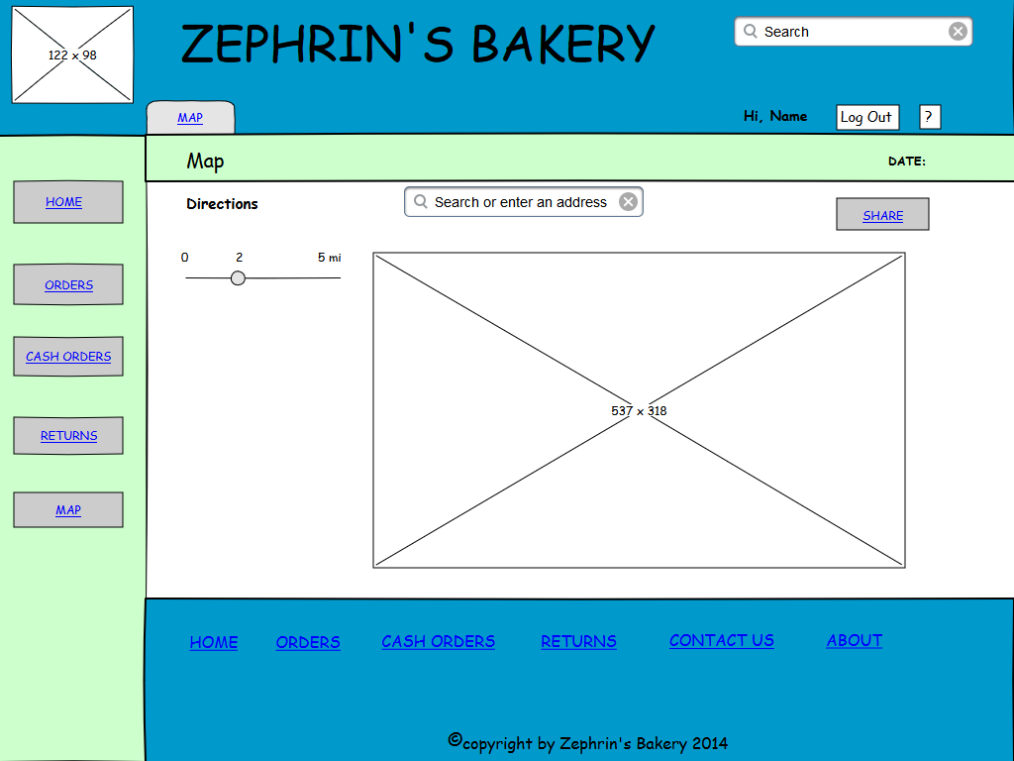

*This figure shows the main page layout showing a map.*

## 10.5 General

### 10.5.1 Tablet Version

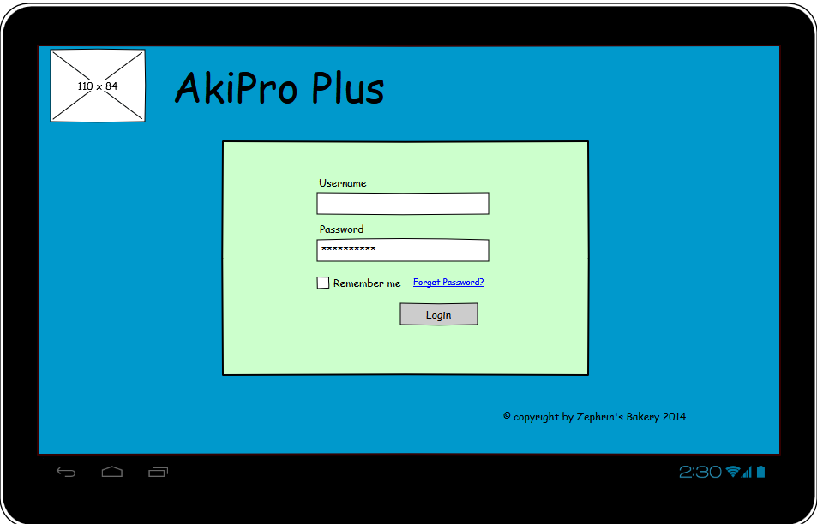

*This figure shows the logging in page.*

### 10.5.2 Mobile Version

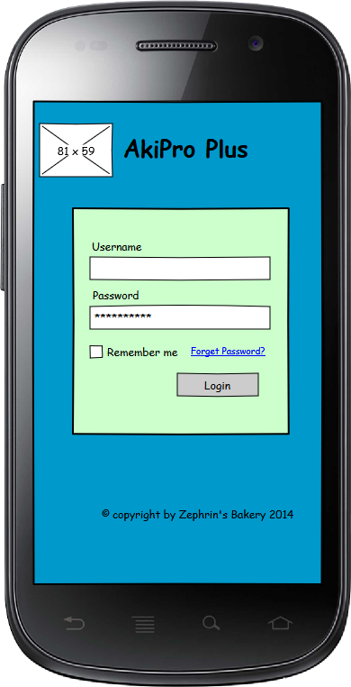

*This figure shows the logging in page.*

### 10.5.3 Desktop Version

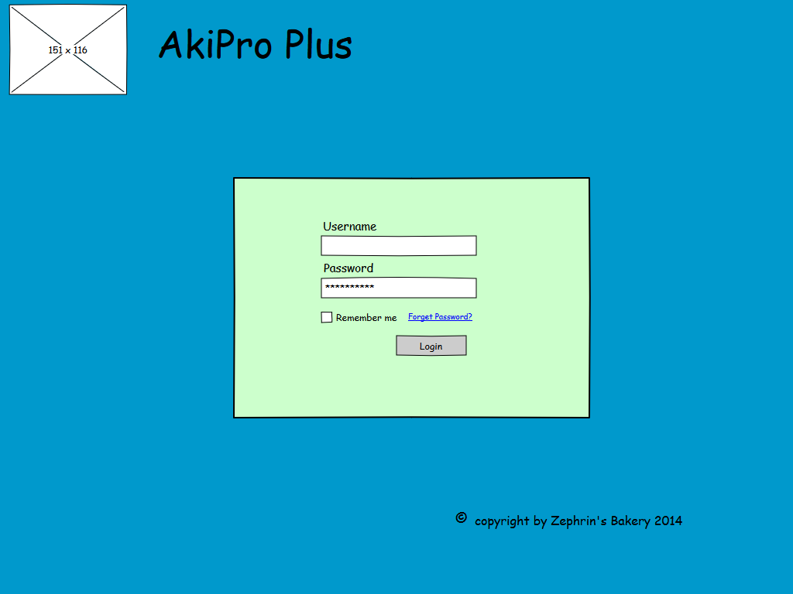

*This figure shows the logging in page.*

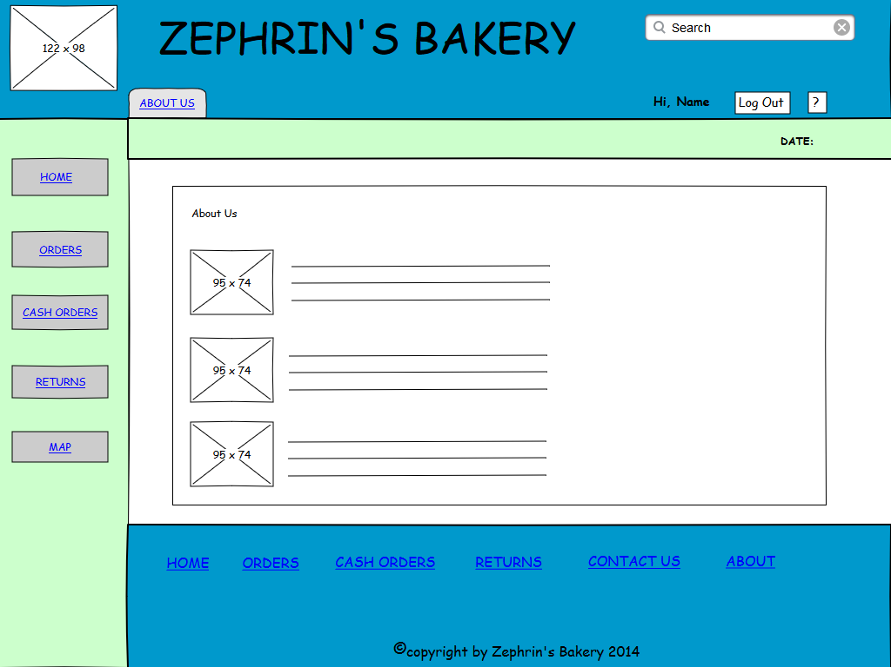

*This figure shows the about us page.*

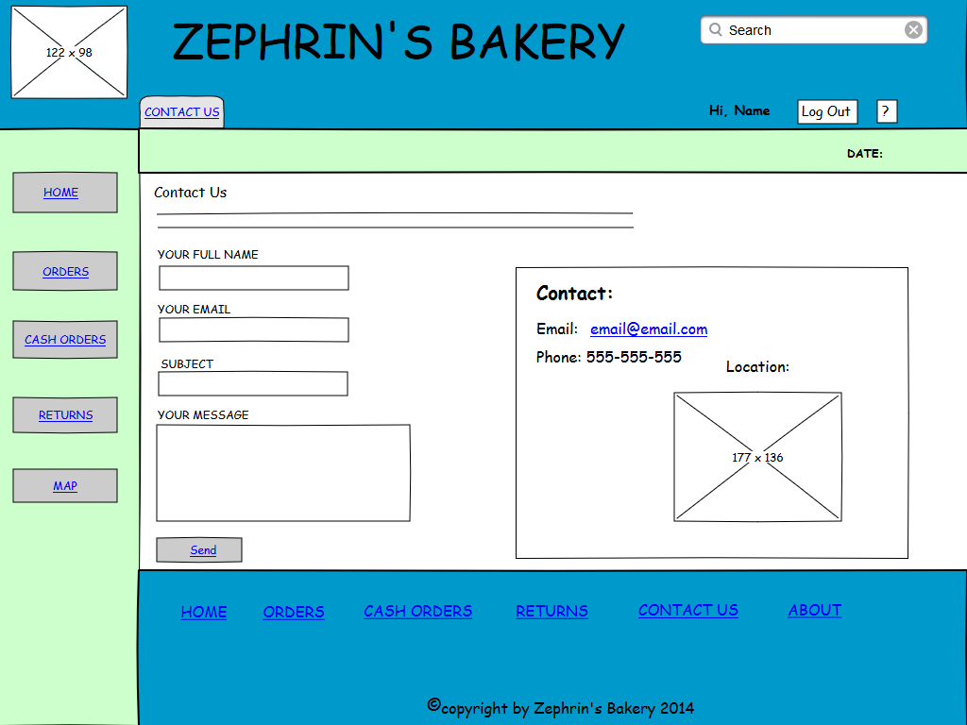

*This figure shows the contact us page*

# Glossary

**Ledger**: This provides all transactions pertaining to an account in a tabular form.

**Note**; a document to show discrepancies with an invoice. This can credit where the original amount of an invoice is decrease while debit note the original amount is increased.

**Receipt**; A signed invoice

**Reports:** a printable version of any document

**Transactions:** any type of documents that can occur in the system. These include credit notes, debit notes, payments, standing orders and orders.